Lab – Least Cost Path from the Shire to Mt. Doom
Lab written by Ashley Roy; Data supplied from Robert Hickey

In this assignment, you’ll look at some Middle Earth data and calculate the least cost path that Frodo and Sam could’ve taken from the Shire to Mordor in order to destroy the One Ring.

To build the dataset, my student took the basic map of Middle Earth, digitized a few features, and then converted those features into cost surfaces. We will be using:
- Distance from travel paths (roads and rivers); (close is bad, as more likely to run into the bad guys). (roads and paths digitized)
- distance from enemy locations; Farther is better (points)
- distance from ally locations; Closer is better. (points)
- travel difficulty through different land types; Pretty self explanatory. (landcover digitized)
- visibility from the Eye of Sauron in different land types; Basically, a modifier on the last criteria. (a different classification of landcover)
- distance from towns; Towns are bad. Bad things can see you. (Towns digitized as points)
- Slope; How hard it is to travel through (calculated from a DEM created from digitized contour lines)
- and visibility from the Eye of Sauron. (based on the Eye point and the DEM)

Instructions
The following are some general instructions that are meant to get you started on the right track without explaining the full details of every step. The data prepared takes you to the point that you have reclassified rasters (1-10) for each criteria.

1. download and unzip the data. Open the boblab1 file. You should see a whole bunch of data. Take a look at all of it before you start rocking on the lab.

2. The criteria that you will be using for this analysis are listed above
a. Looking at the criteria you should’ve noticed that you do not have what you need to get started right away, and you’d be right. So, you will be creating some of this data yourself.

DO NOT DO THE BELOW UNTIL I SAY SO (already done for you, but you should know how this works)

Data creation
1. Ally and Enemy locations (and Source Points)
a. Go into the attribute table for the Towns point data set and add in a new field for the “Ally” locations and the “Enemy” locations. Then add in whether or not each town is either an ally or enemy, leave neutral towns as null entries. (Make sure that you enter in them the same way every time!)
b. Do an attribute selection for what towns are an “ally” and another for who are “enemies.” Export the selected features to their own layer.
c. Also add in the source points (start [Shire], intermediate [Rivendell] end [Mt. Doom]) you will use them later on.
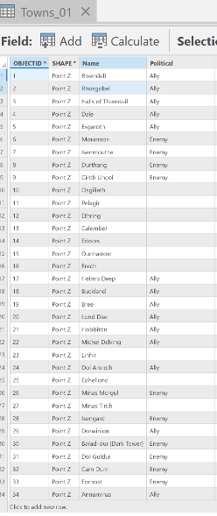
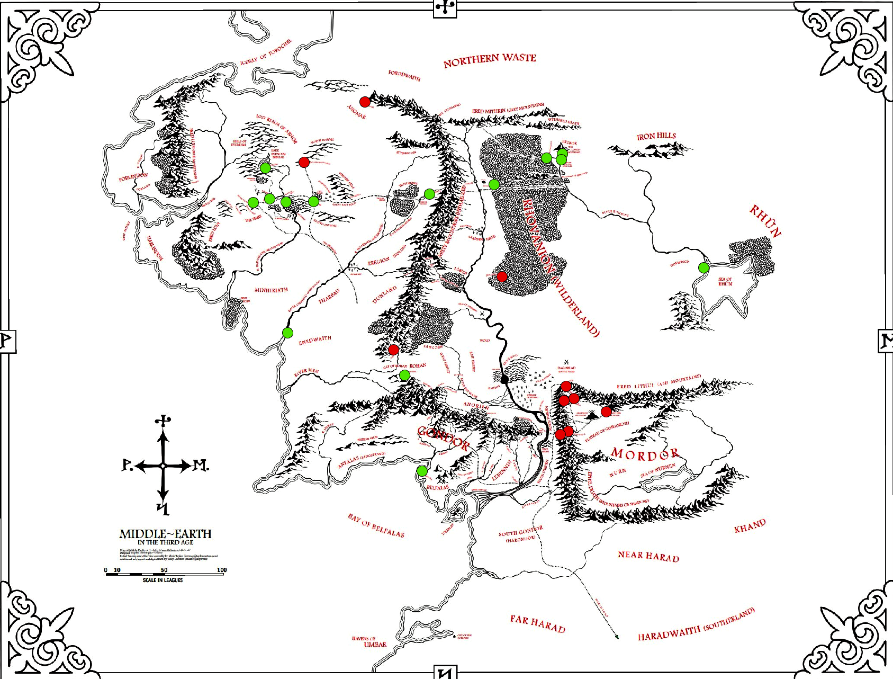
Resulting map should look something like this (green= allies; red= enemies).

2. Slope and Visibility
a. Take the Contour line data and run the “Topo to Raster” tool on it. This turns the contour lines into a DEM.
b. Take your new DEM layer and run the “Slope” tool on it to get a slope layer.
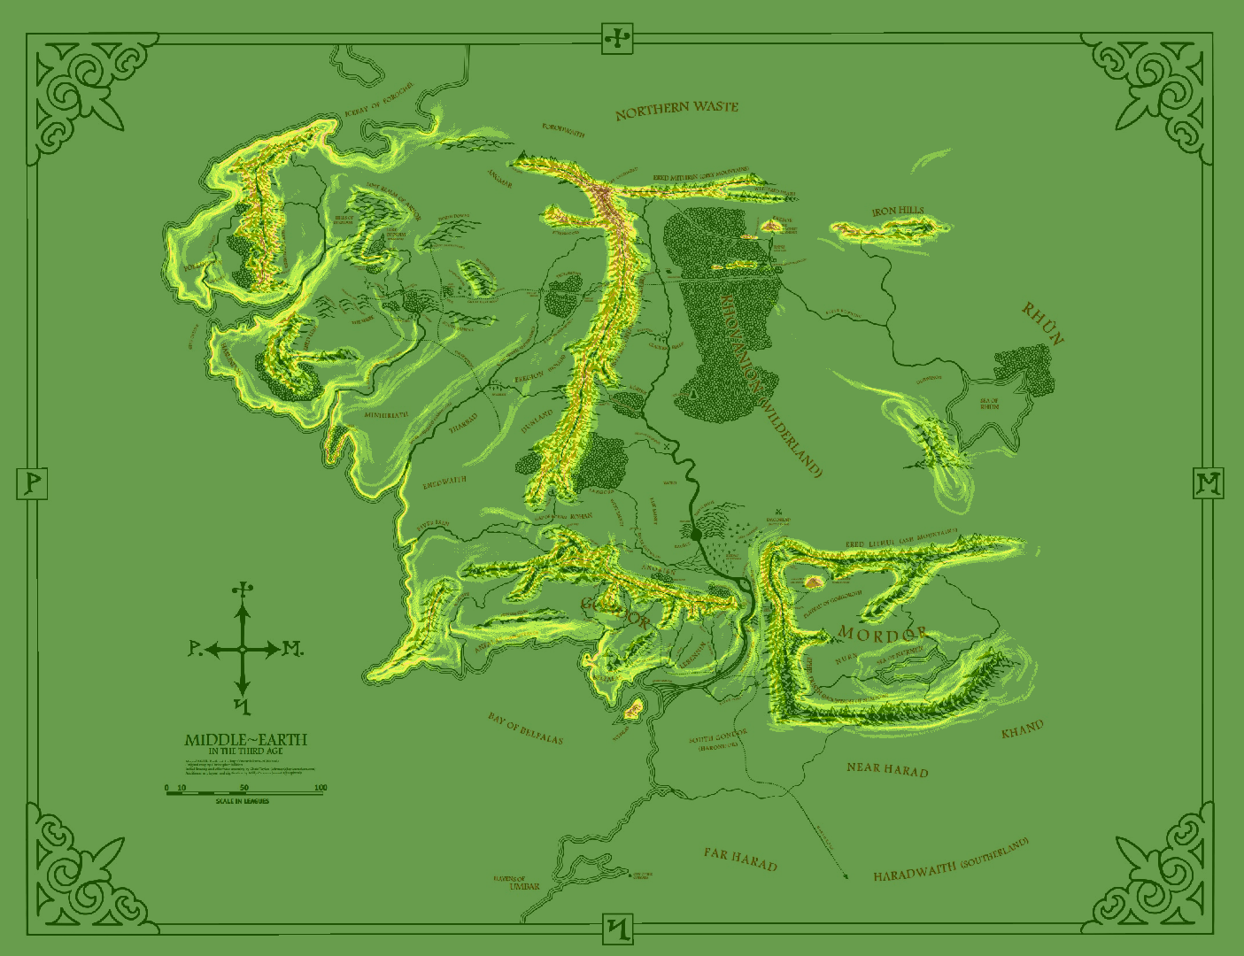
Resulting map should look something like this (high slope = white; low slope = green)

c. Make a point of the location of the Eye of Sauron then once again, take your DEM layer and run the “Visibility” tool on it. Keep in mind that the Eye of Sauron is 5000ft tall.
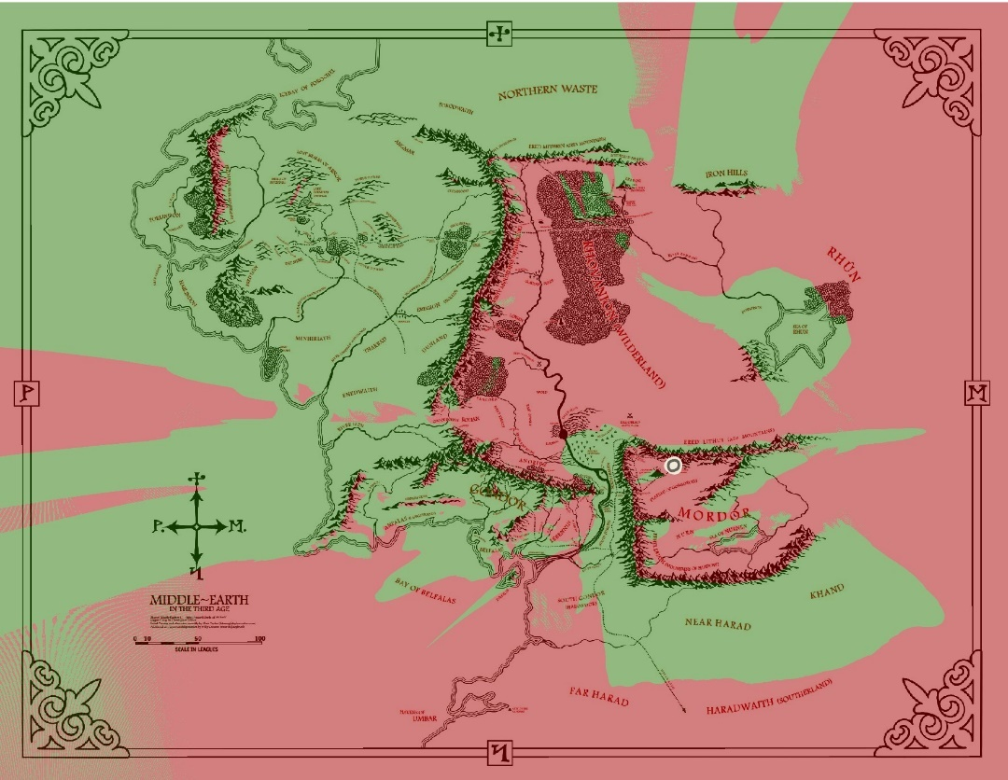
Result should look something like this (red = visible; green = not visible)

3. Combined land coverage
a. Since the land, ocean and land cover layers are separate you will have to combine them.
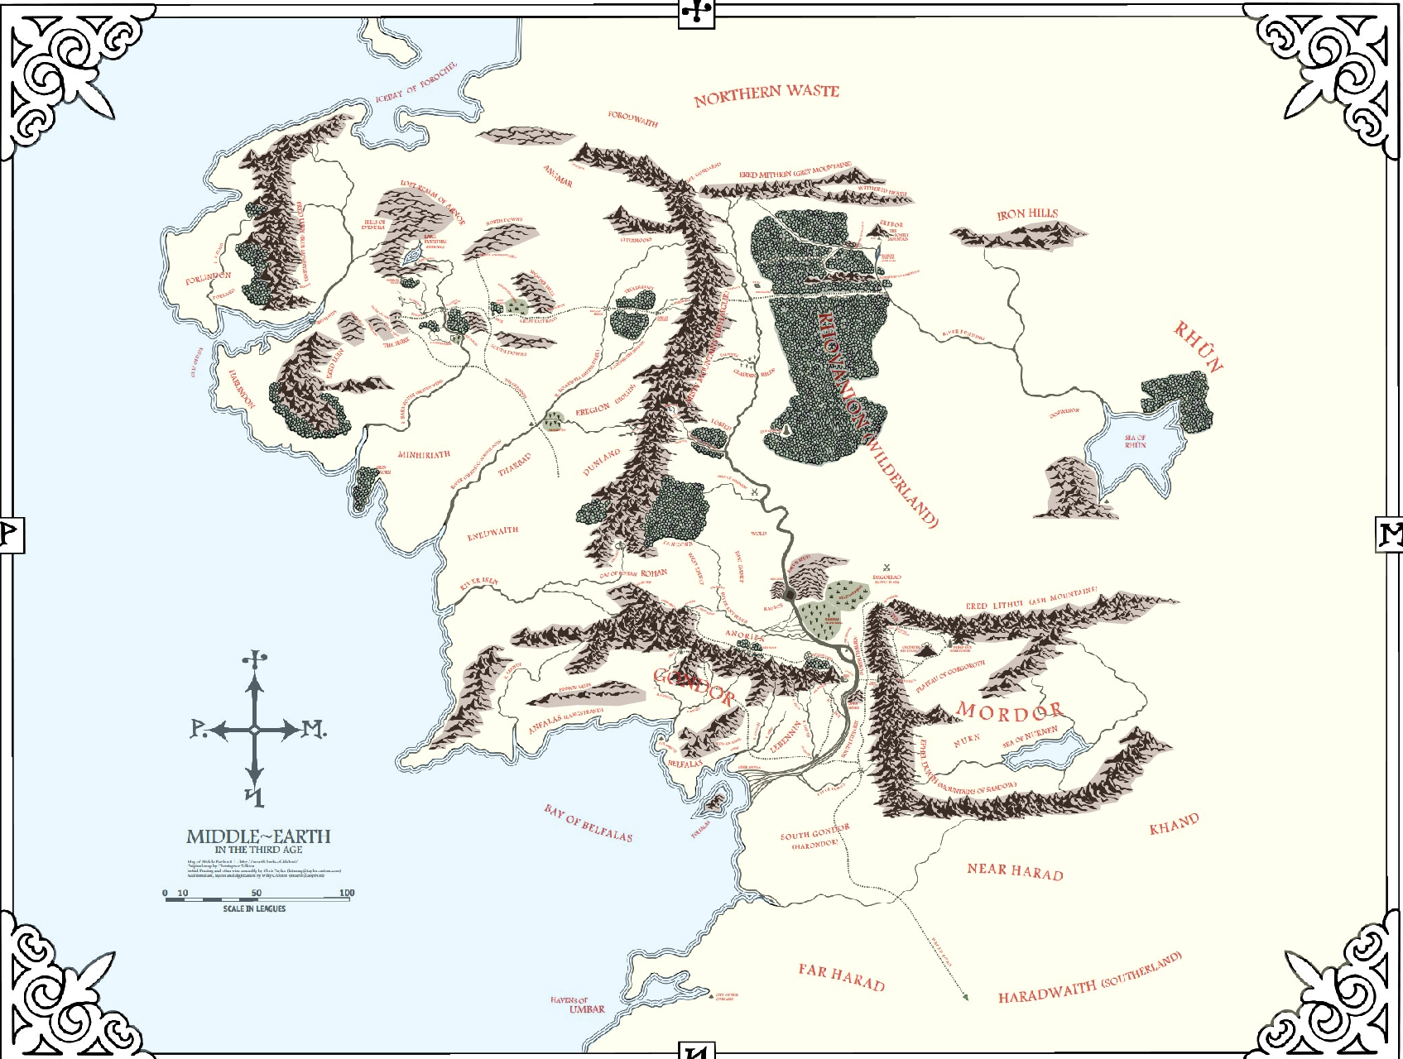
Should look something like this (symbology doesn’t matter right now).
3. Now you have all of the preliminary data you need to continue. But before you do anything else, make sure that ALL of your data is converted to raster’s.

4. On the roads, enemy locations, ally locations, and town layers run the Euclidean distance tool. 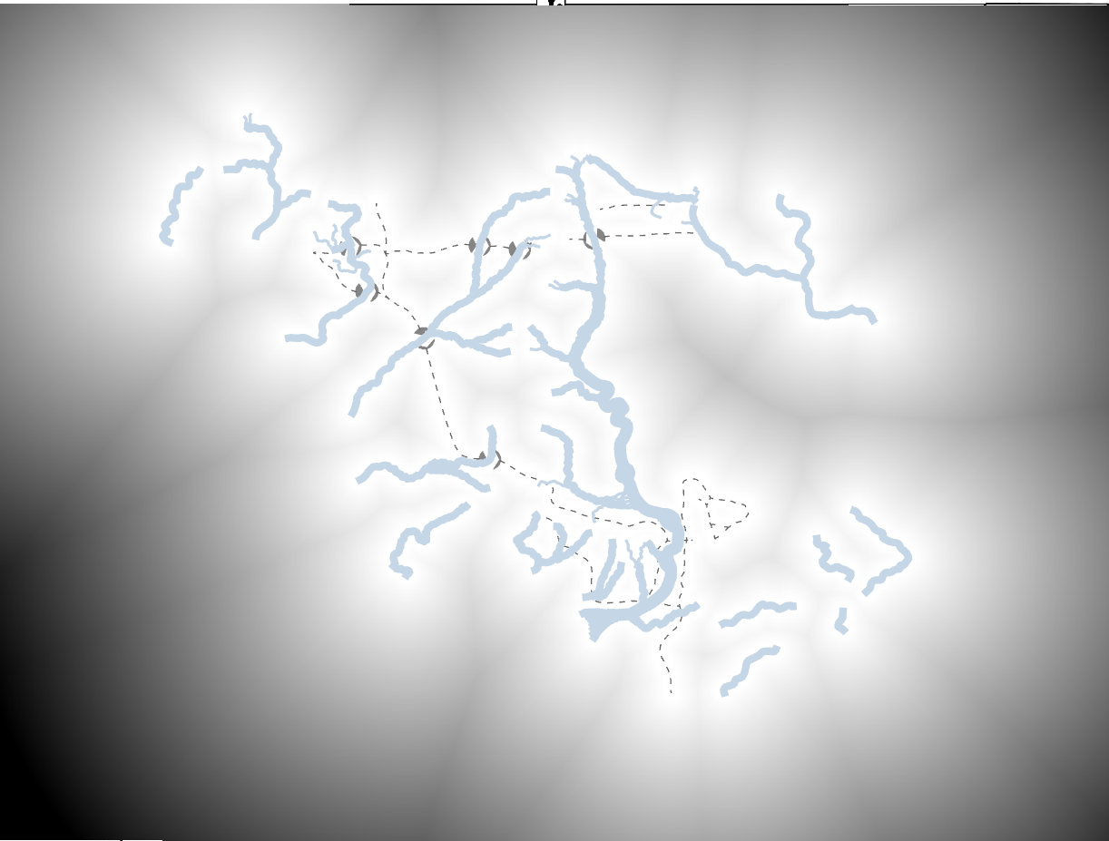 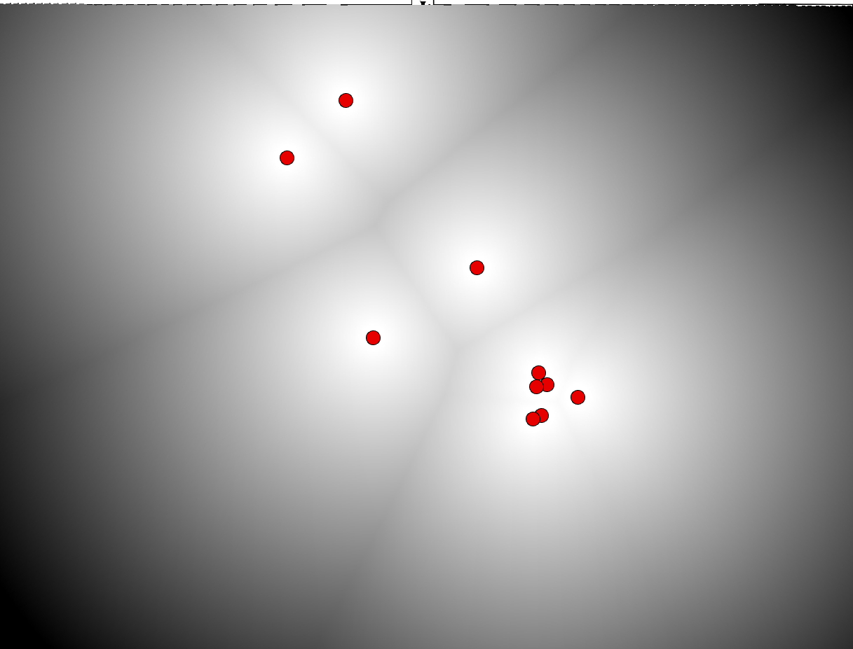
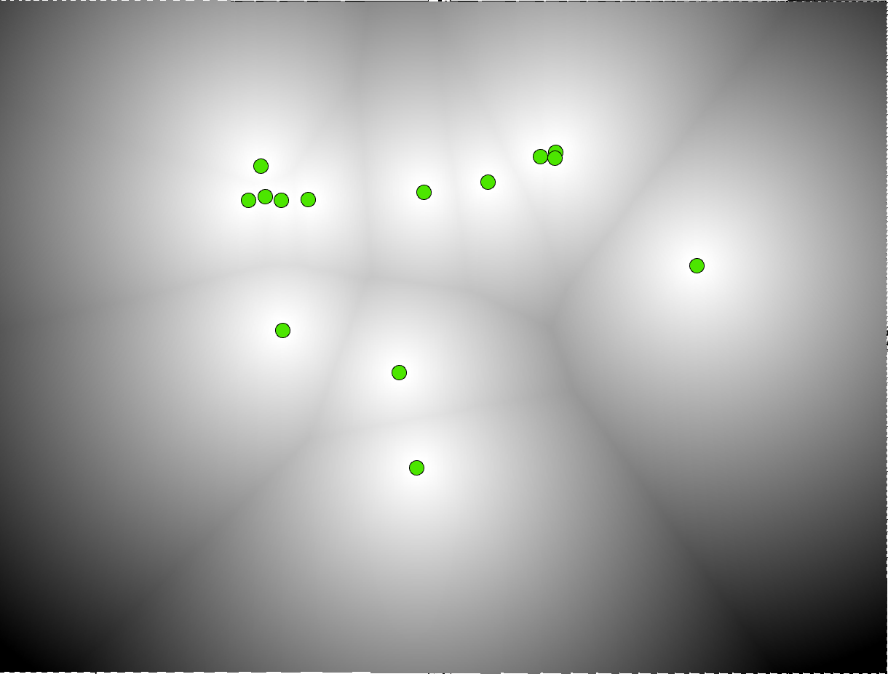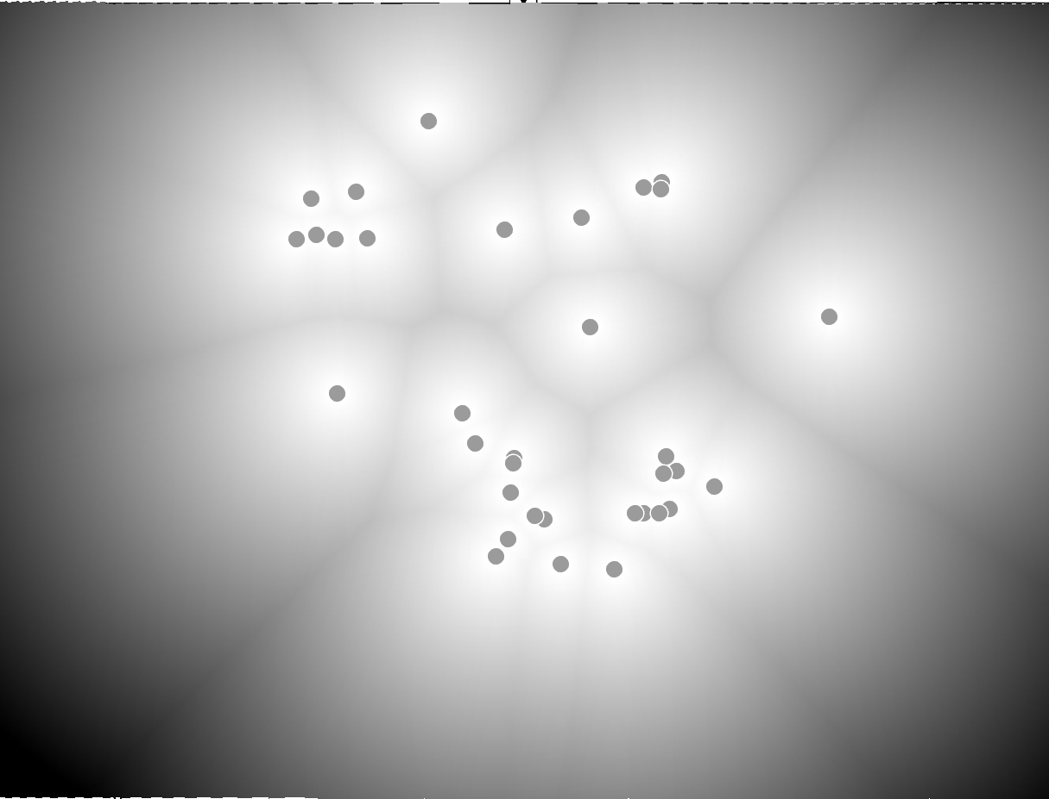
(white areas are closer/black areas are further)

5. Reclassifying. Use the “Reclassify” tool to reclassify all of your criteria into a 1-10 scale with 1 being low risk/cost and 10 being high risk/cost (you do not have to use the full 1-10 scale; you can just use 2 and 8…etc. just make sure you use the same color scale).

a. Distance from travel paths: Further has less risk. (Less chance of being recognized or running into enemies)
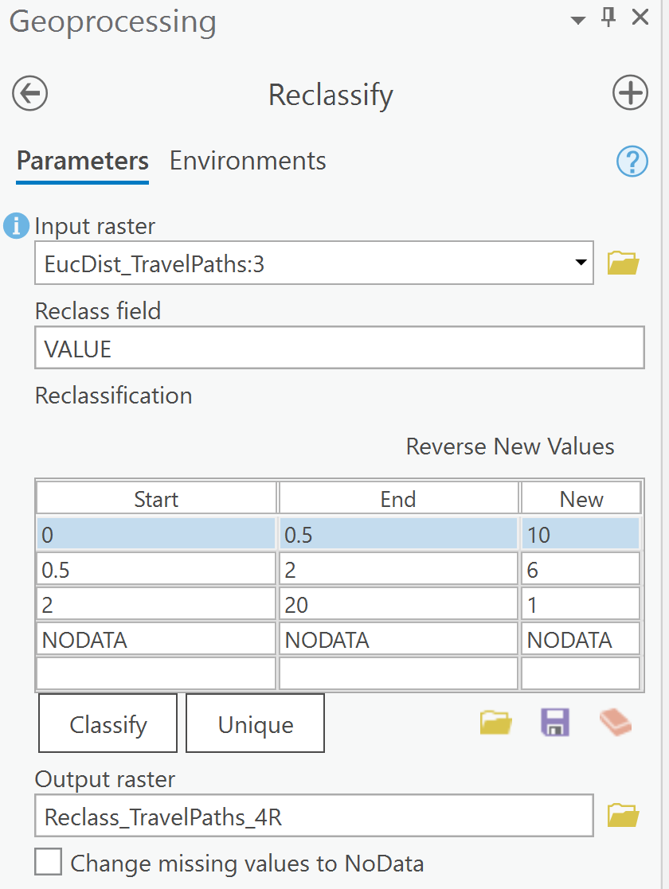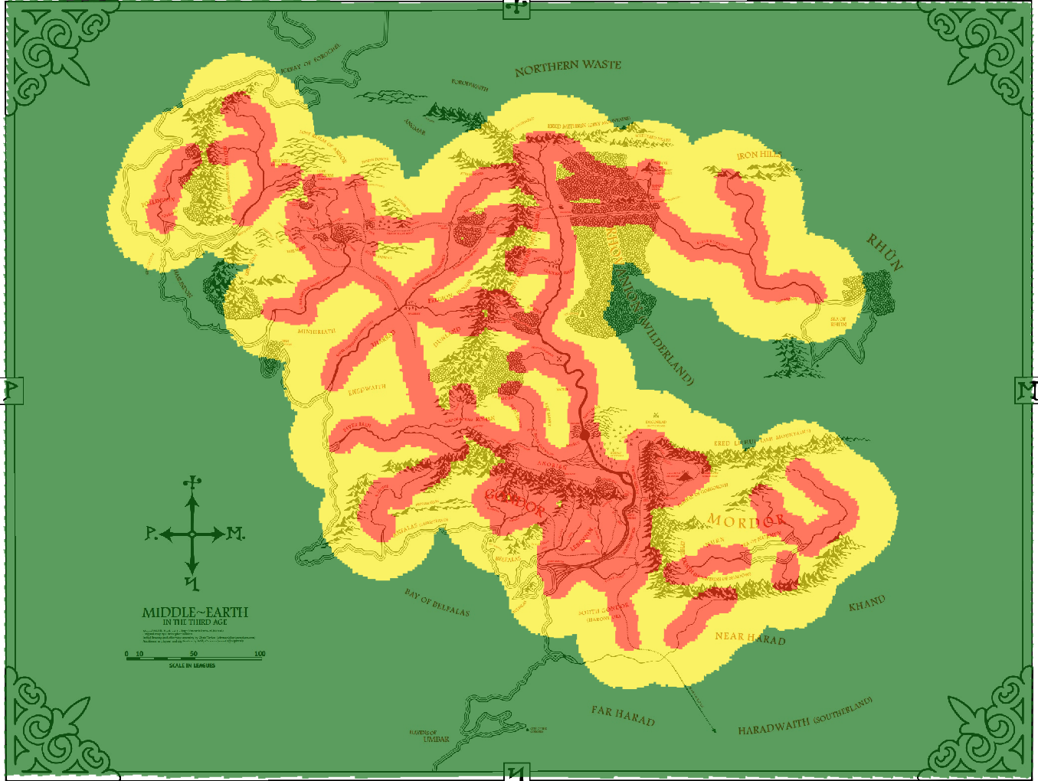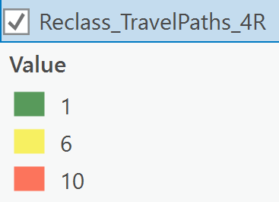

b. Distance from enemy locations: Further has less risk.
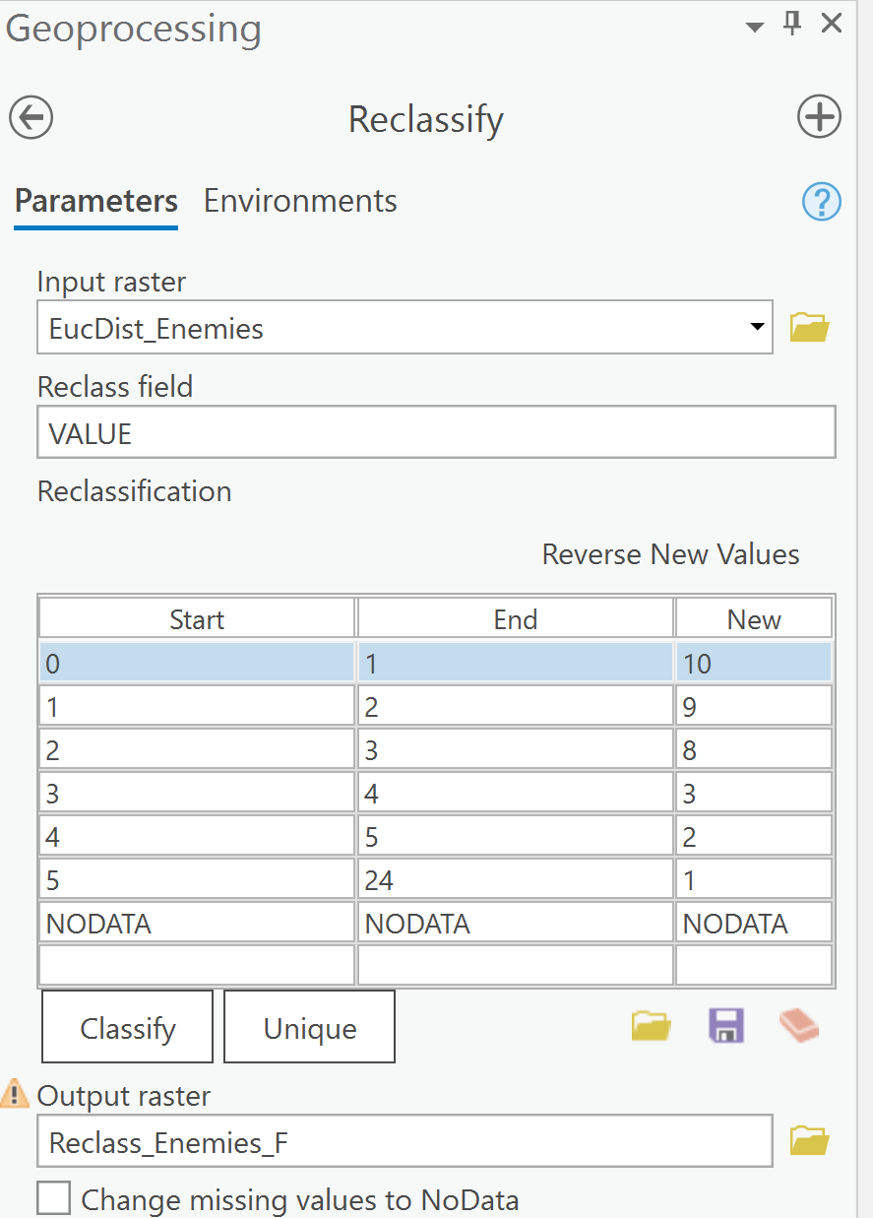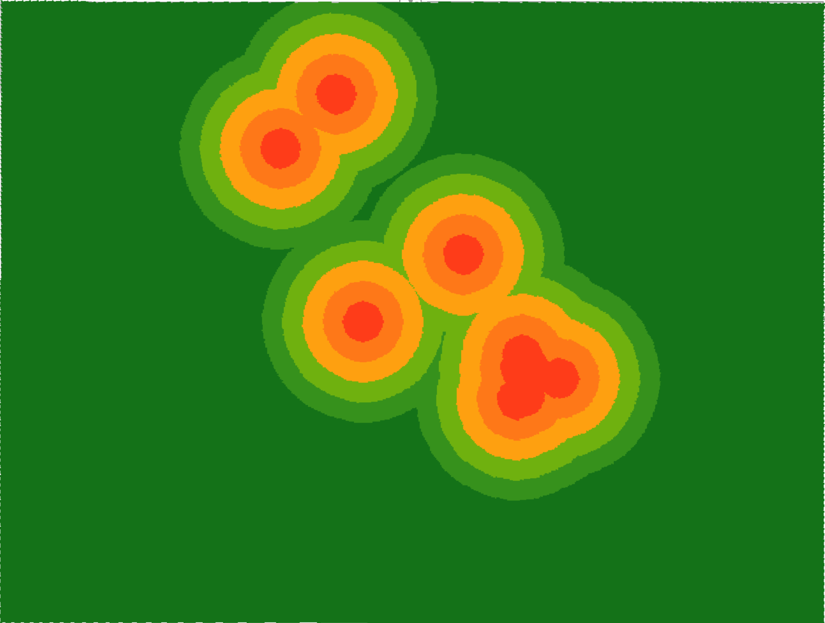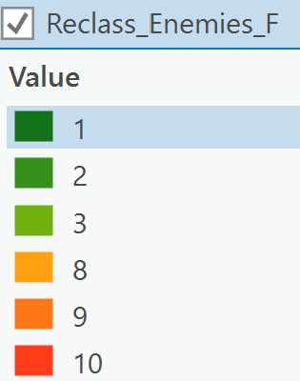

c. Distance from ally locations: Closer has less risk.
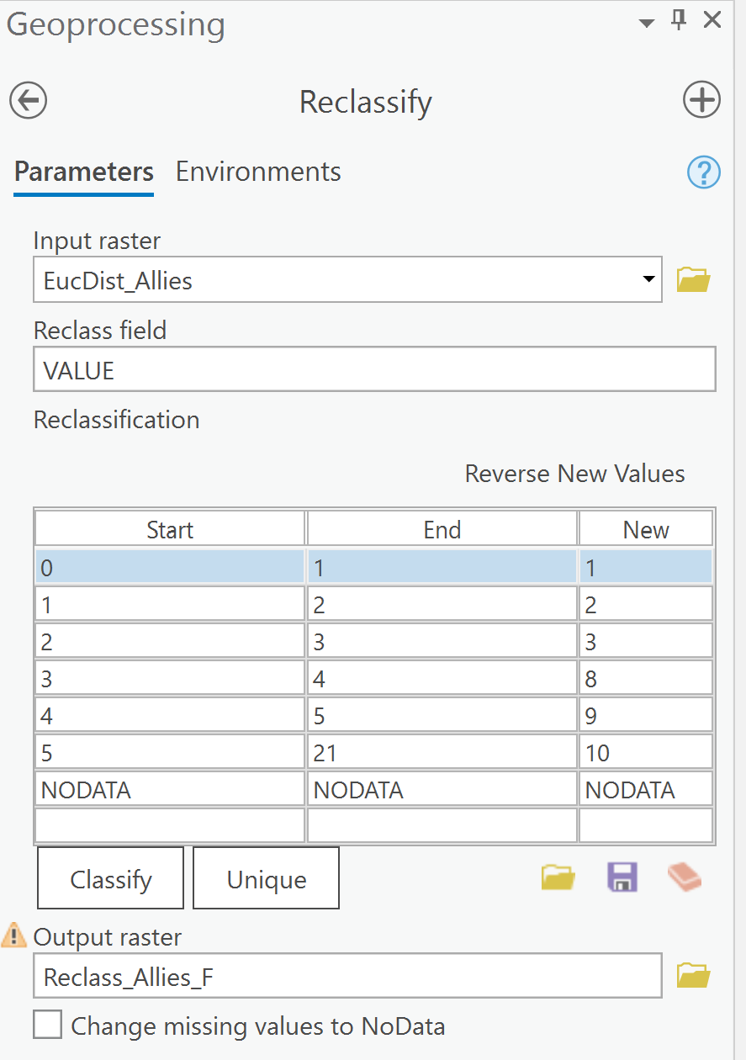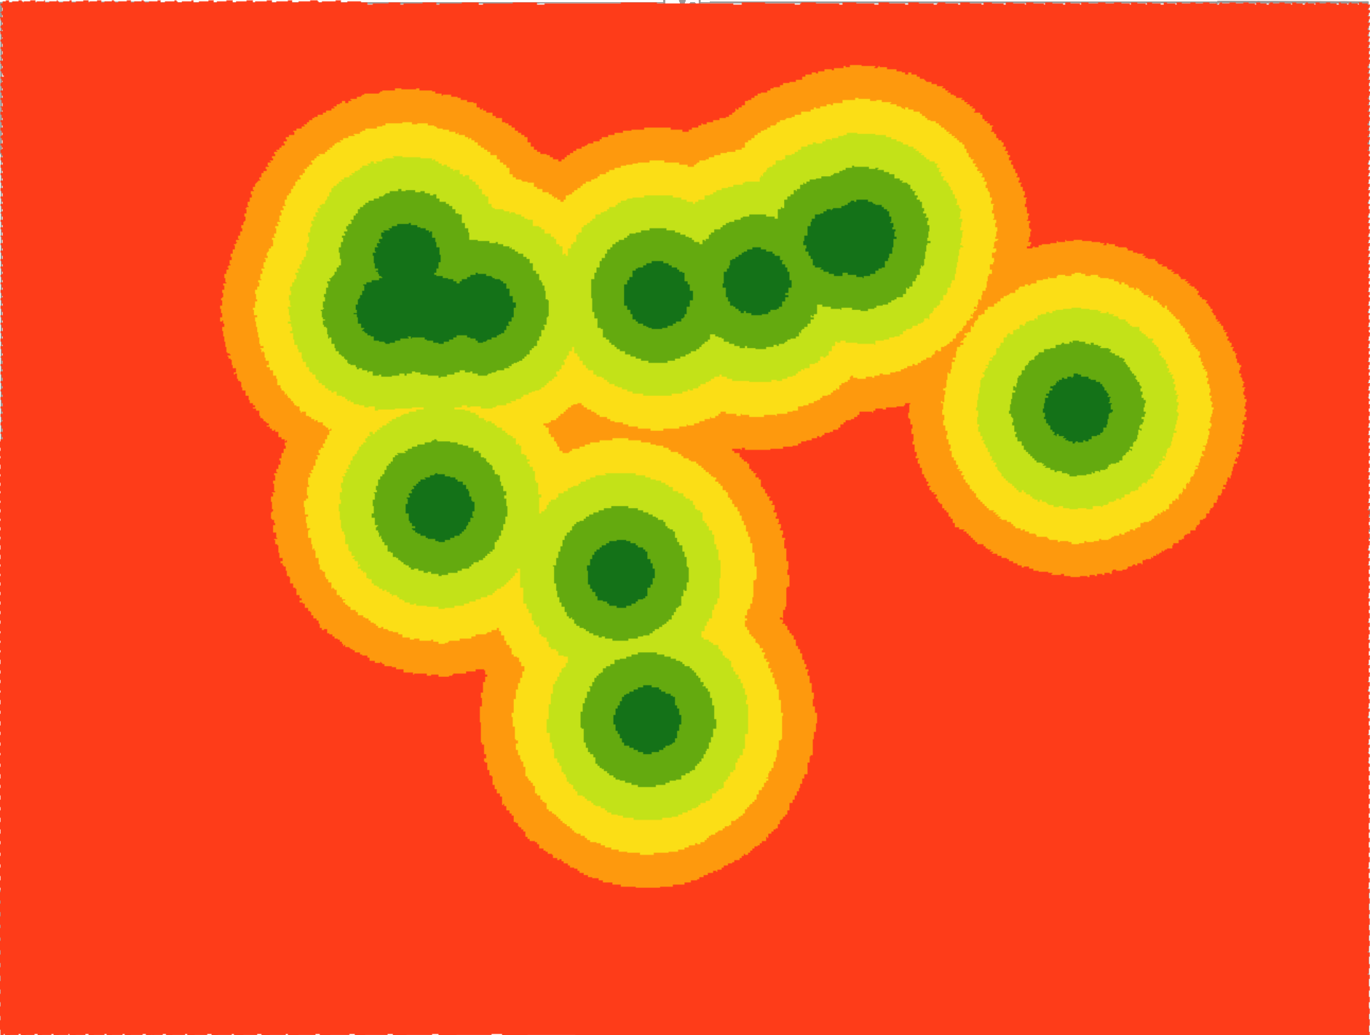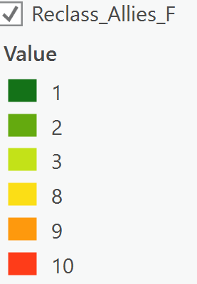

d. Travel difficulty over land types: Plains have the least risk. (Plains will have less uneven terrain and clear visibility around them (making navigation easier))
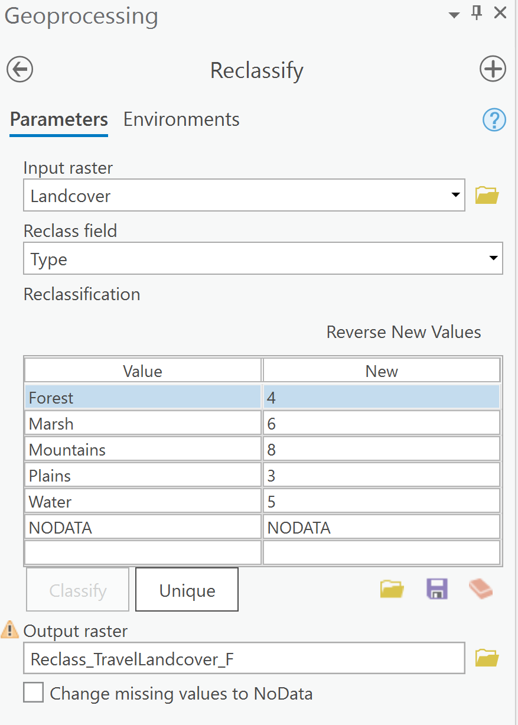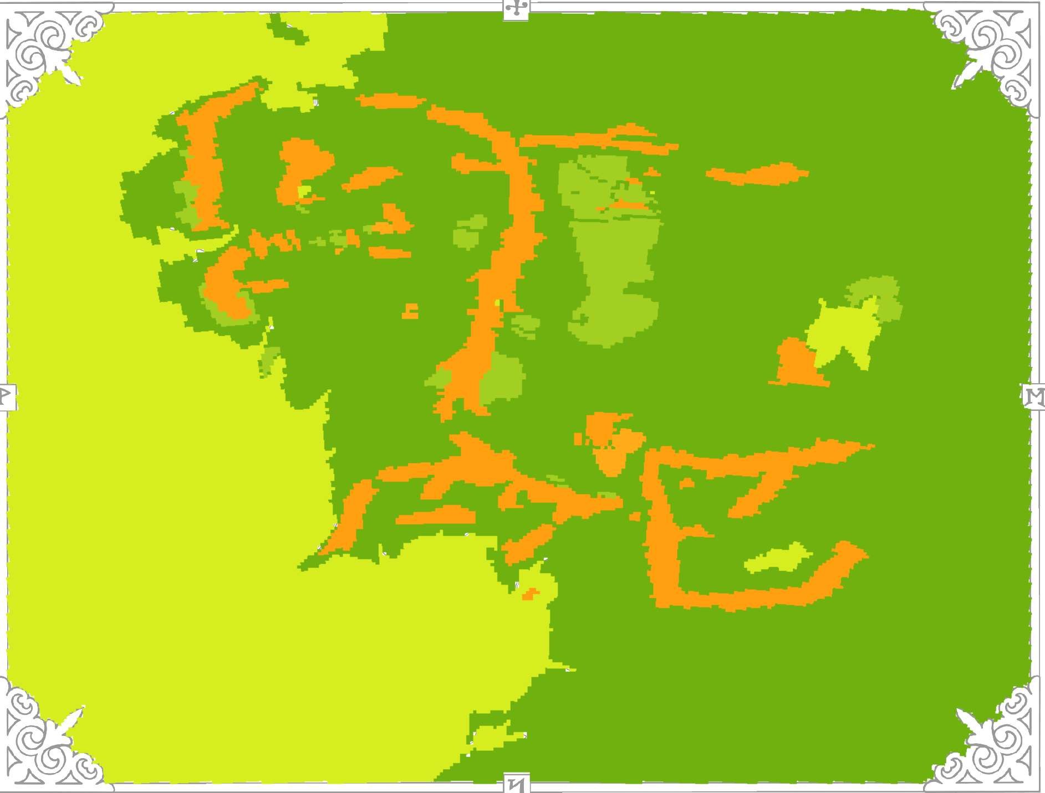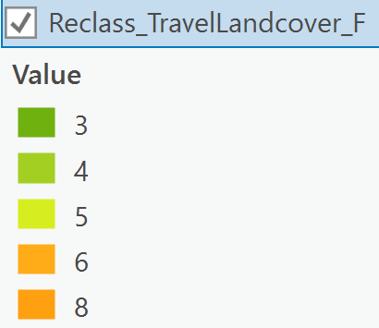
e. Visibility from land types: Plains have the most risk/Forests have the least. (Plains leave you out in the open and vulnerable to attacks/forests provide cover)
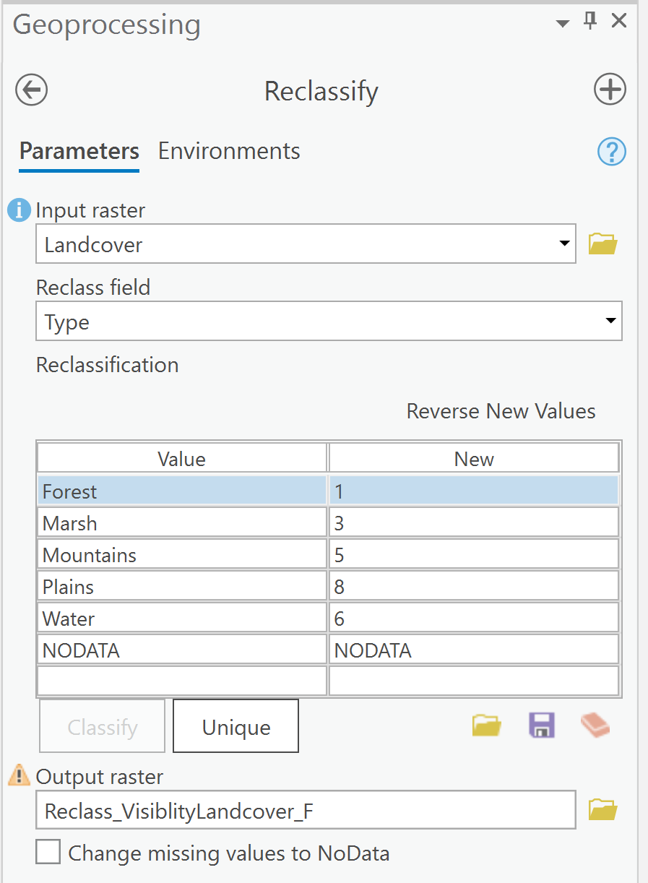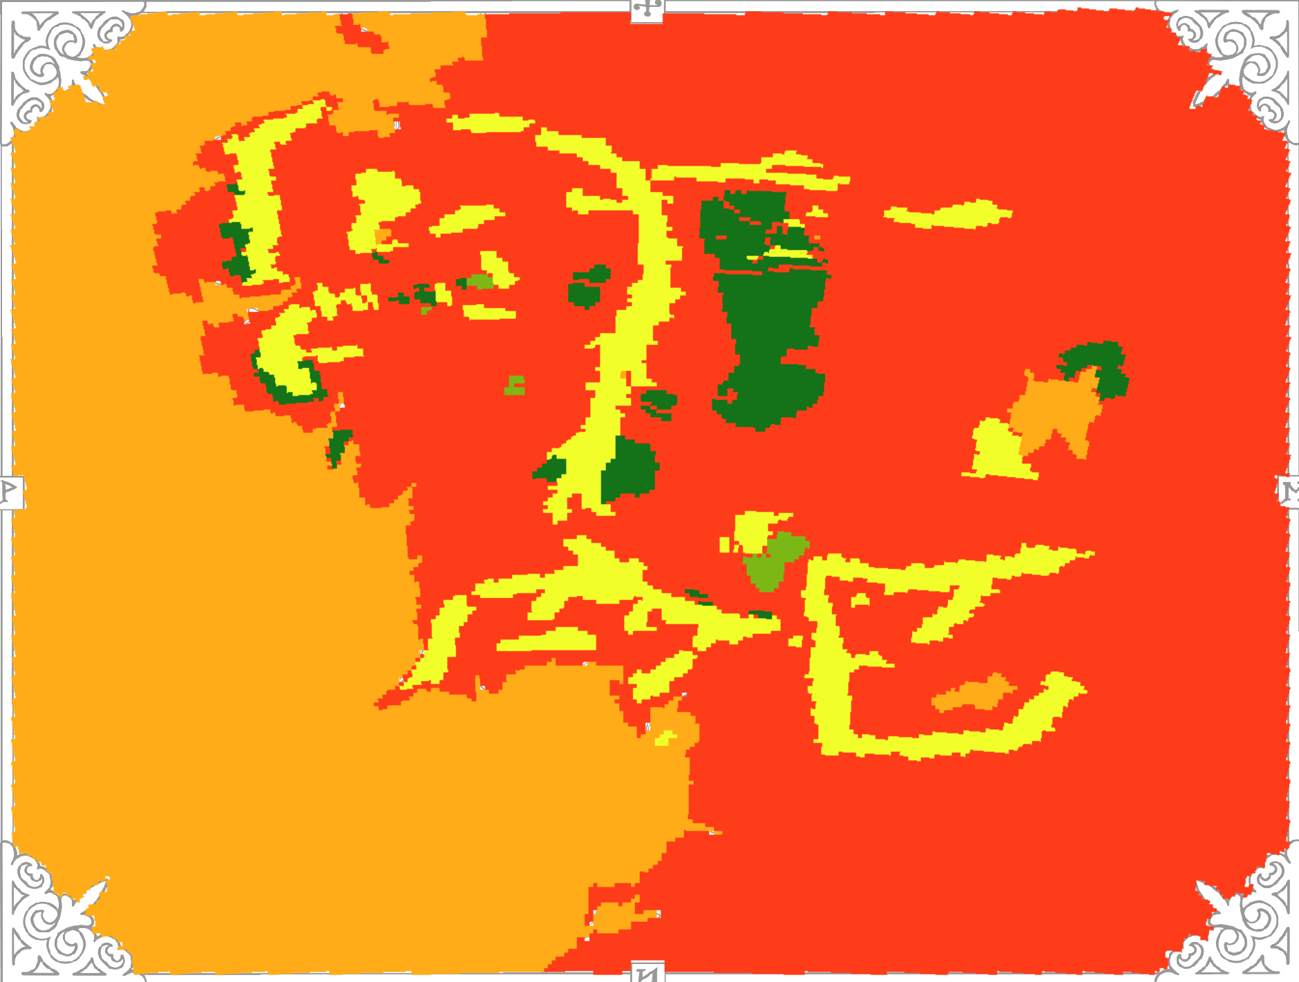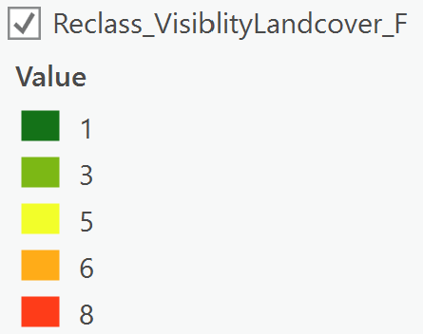
f. Distance from towns: Further has less risk. (Less chance of being slowed down by side quests/risking being recognized)
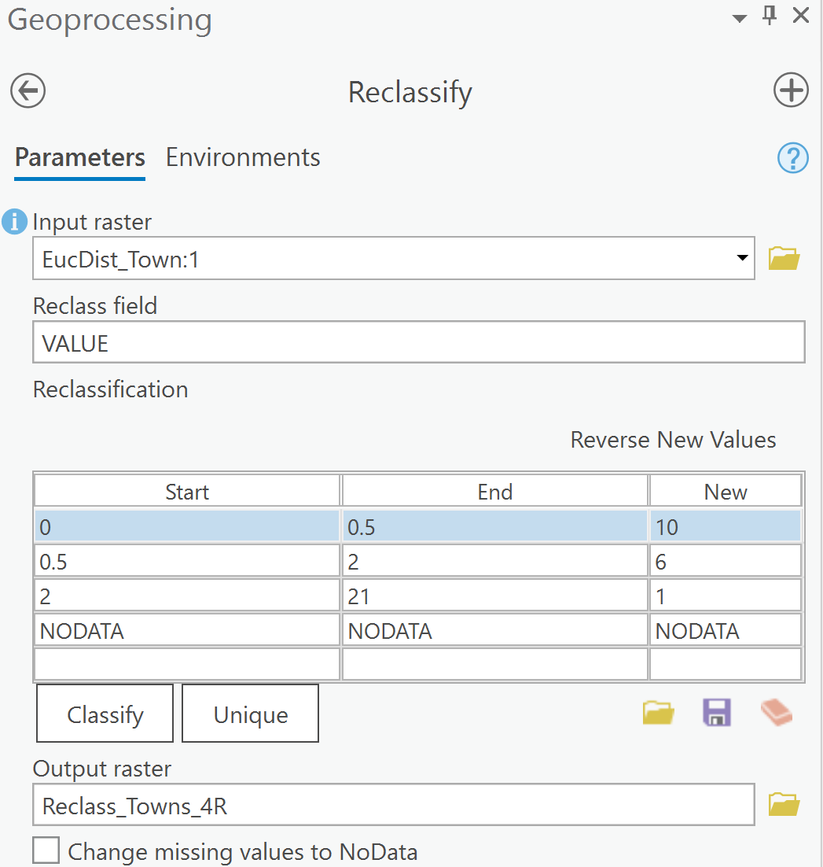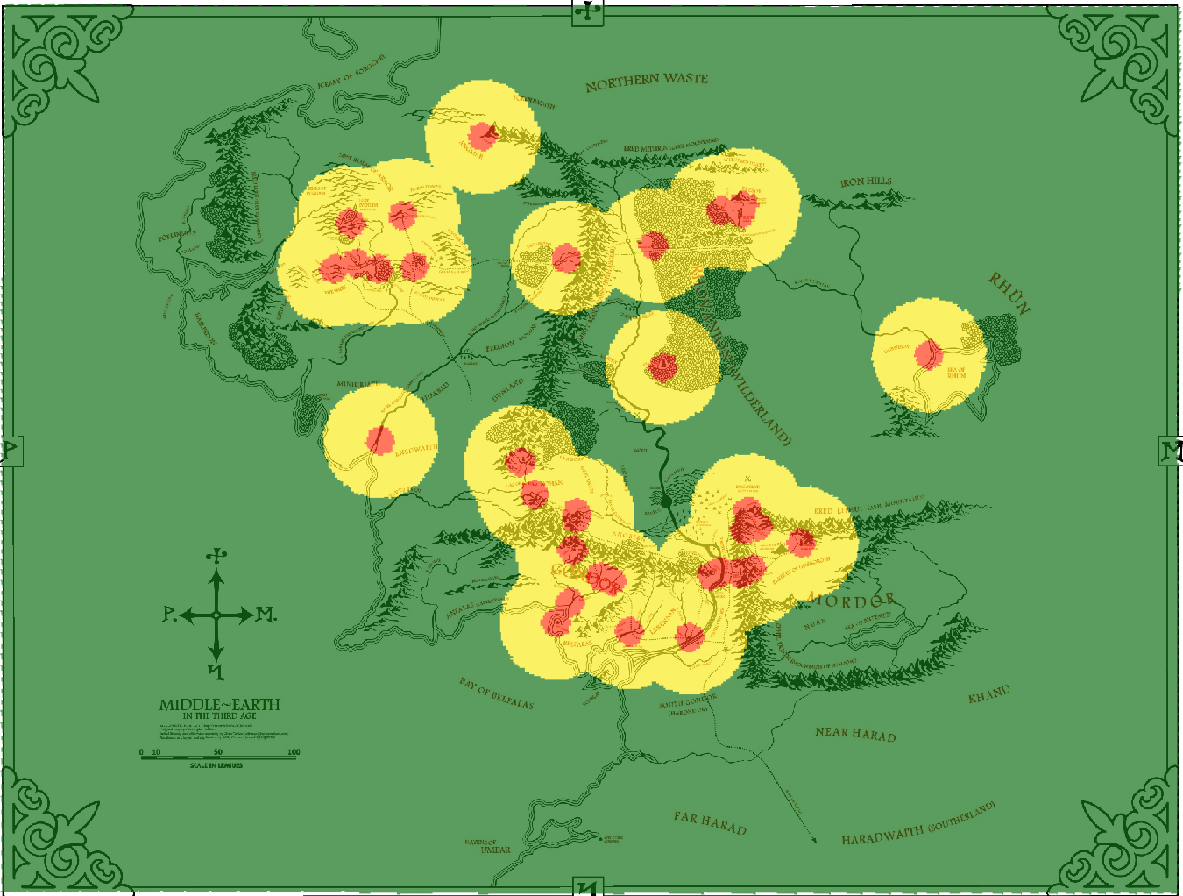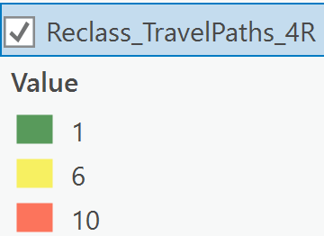

g. Slope: Flatter has less risk. (Low slope degree makes travel easier and faster)
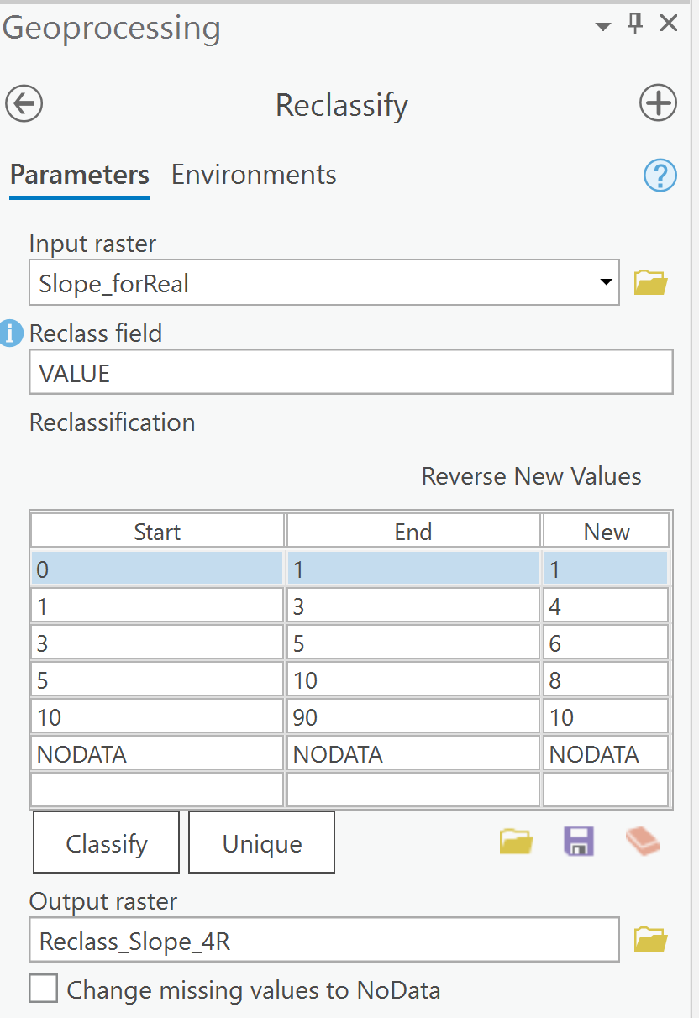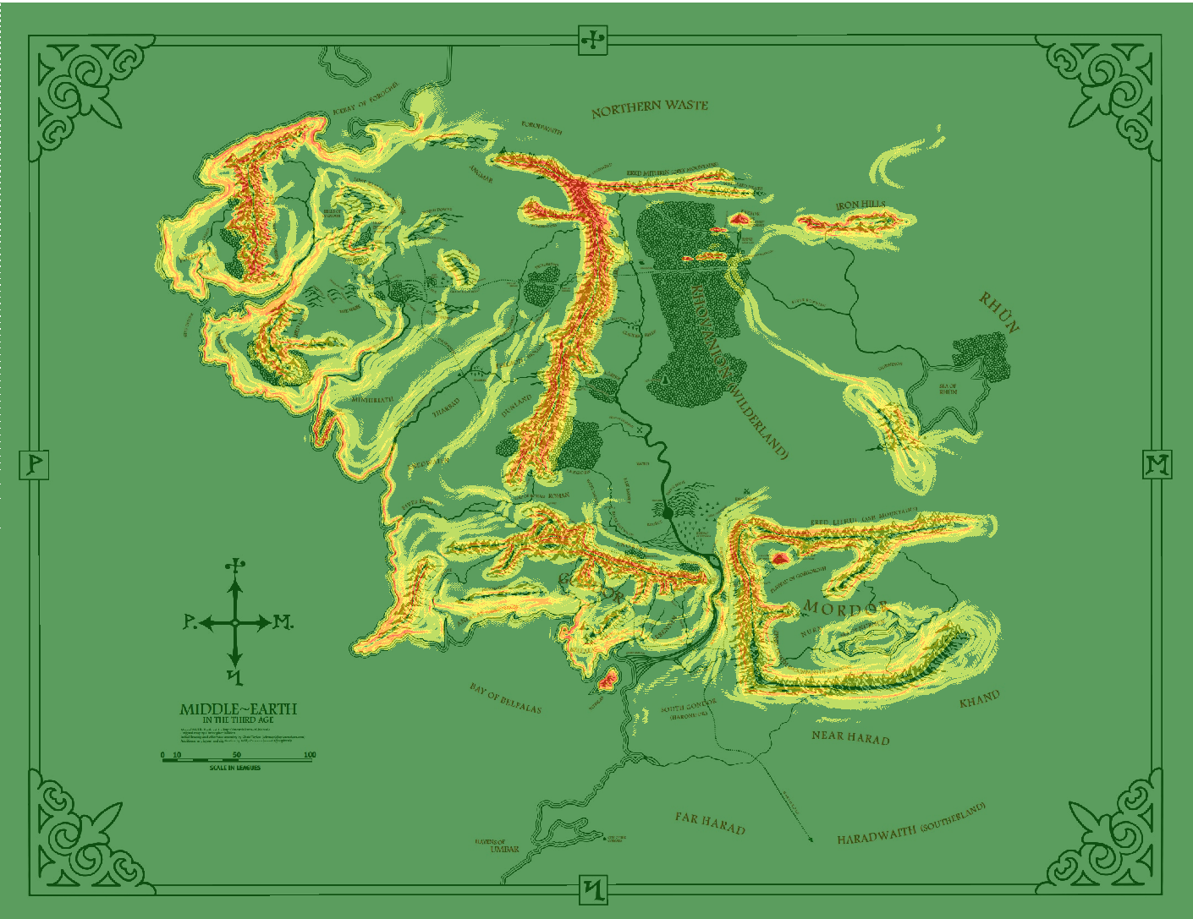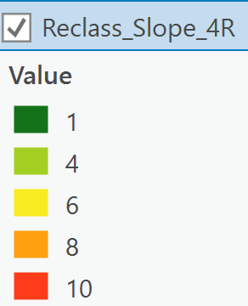
h. Visibility from the Eye of Sauron: Hidden has less risk. (If Sauron sees them the Ring wraiths will attack!)
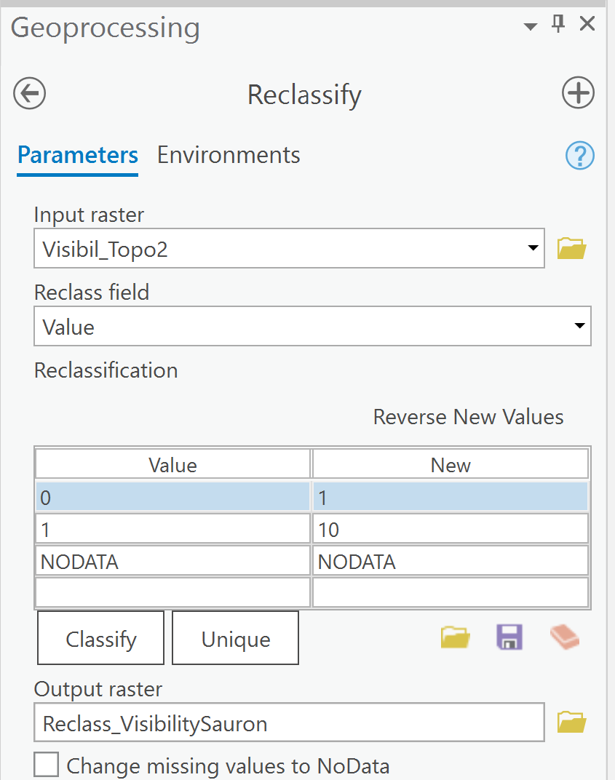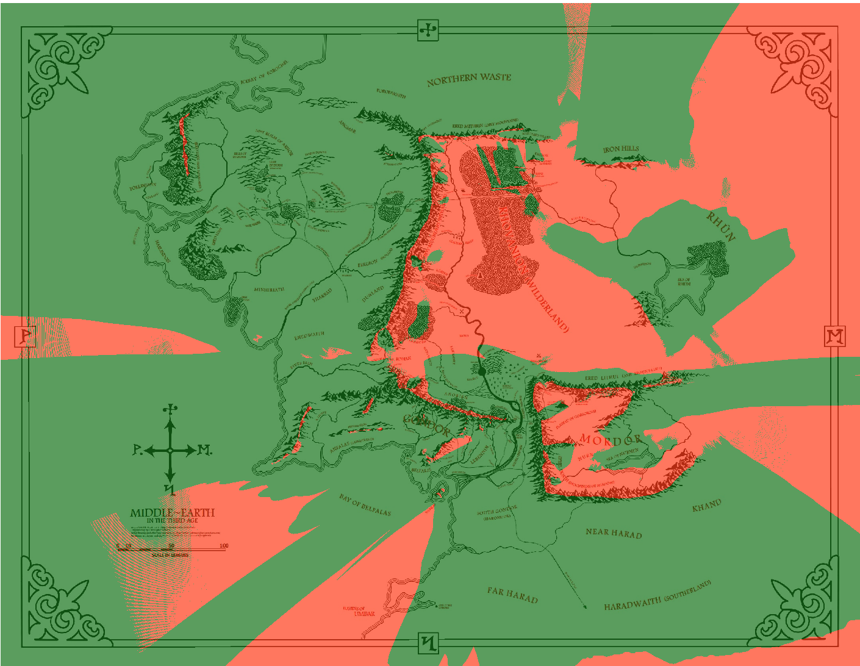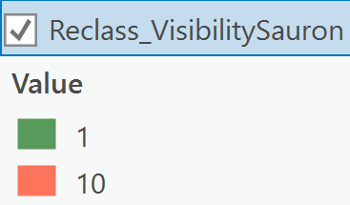

OK. TIME FOR YOU TO START DOING GIS STUFF

At this point, you have 8 layers that have been reclassed such that low values are good and high values are bad (all on a 1-10 scale). These are the relcassed layers you see in Pro.

However, you need to have a single “cost” raster based on these 8 layers. If you were to think that all these have the same impact, you would simply add them together and divide by 8 – thus retaining the initial 1-10 scale. Now, though, let’s assume they aren’t all equal and you will make up weights – assume all your weights sum to one. Then we can just take each raster layer, multiply it by it’s weight, and add it to the other layers. Again, this leaves us with a raster layer that stays 1-10, where low is good and high is bad

Now
6. Make up weights for each of the criteria (how important they are), just make sure that they add up to 1 when you are done.
I weighted them as such: (don’t feel like you have to use my values – your final paths will look different if you use different weights – and that’s cool)
- Distance from travel paths (.08)
- Distance from enemy locations (.17)
- Distance from ally locations (.17)
- Travel difficulty over land types (.15)
- Visibility from land types (.05)
- Distance from towns (.08)
- Slope (.25)
- Visibility from the Eye of Sauron (.05)
You will be multiplying your criteria by these weights in the next step.

7. Use the “Raster Calculator” to add all of your layers together in this fashion:
(C1*W1)+(C2*W2)+(C3*W3)+…(C8*W8)
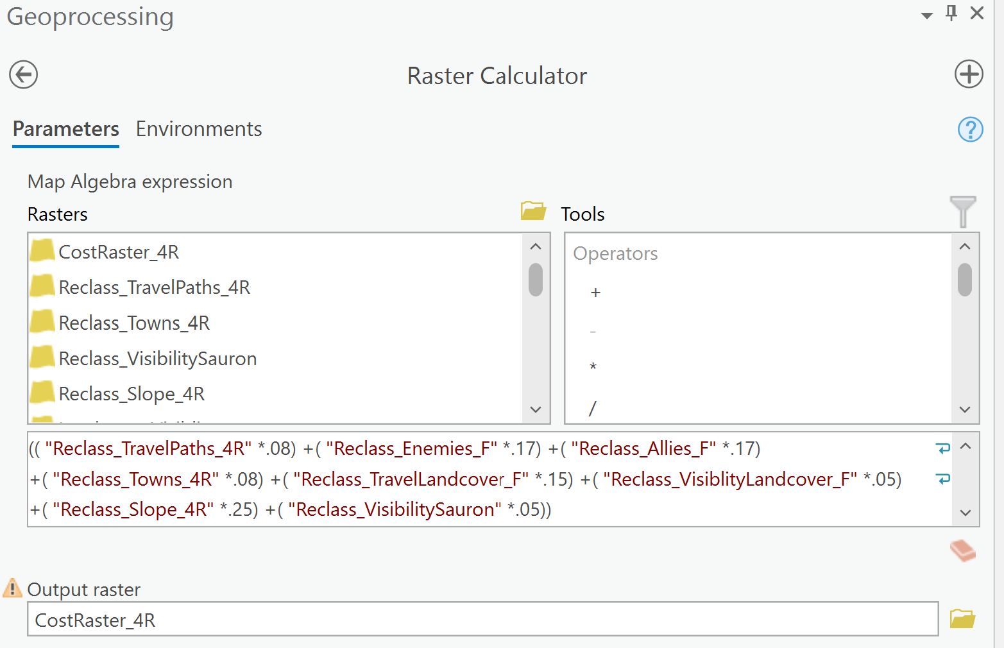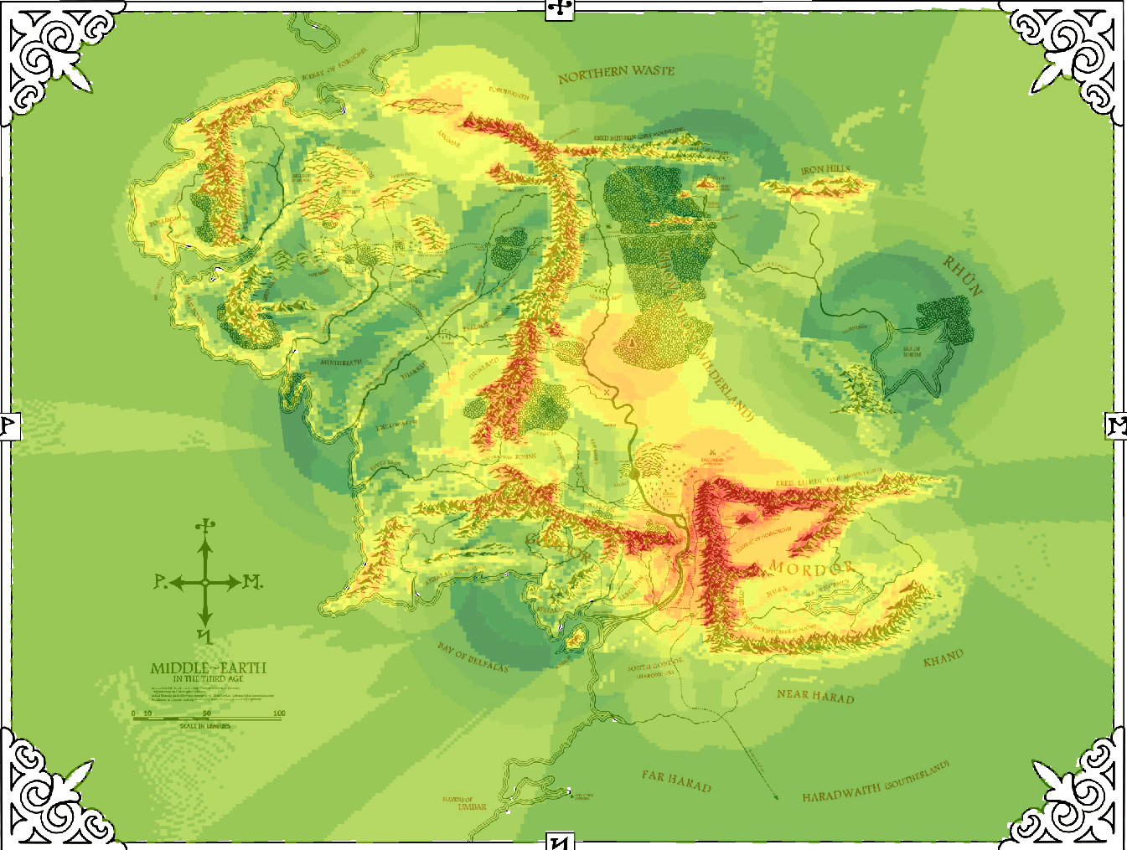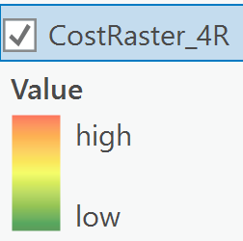
Now you will have a total cost raster. Depending on your weights, these could look very different.

It’s time to start the process of calculating the least expensive cost paths.

8. Take your cost raster and the source points and put them into the “Cost Distance” tool. This will give you a distance raster and back link raster.

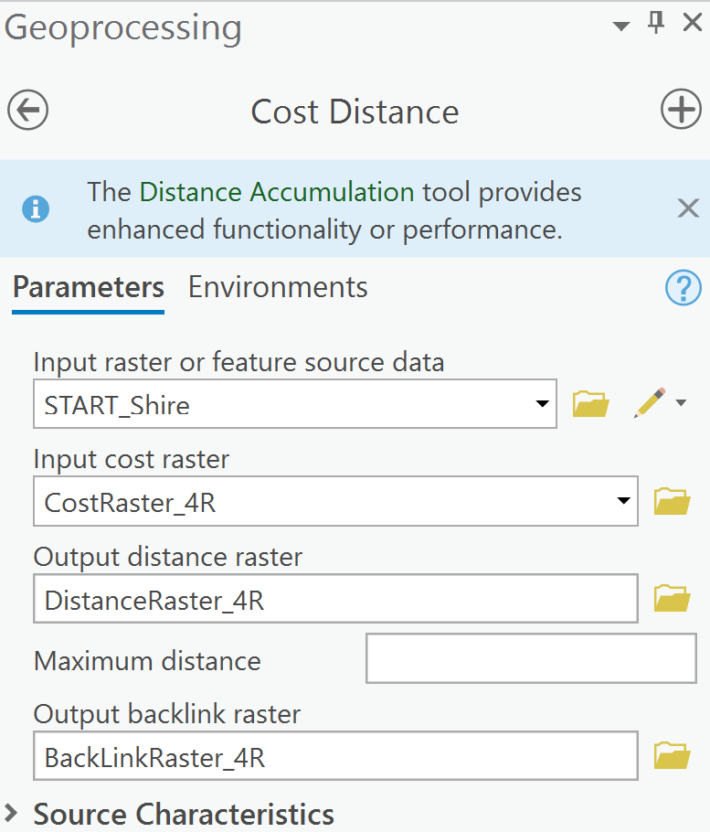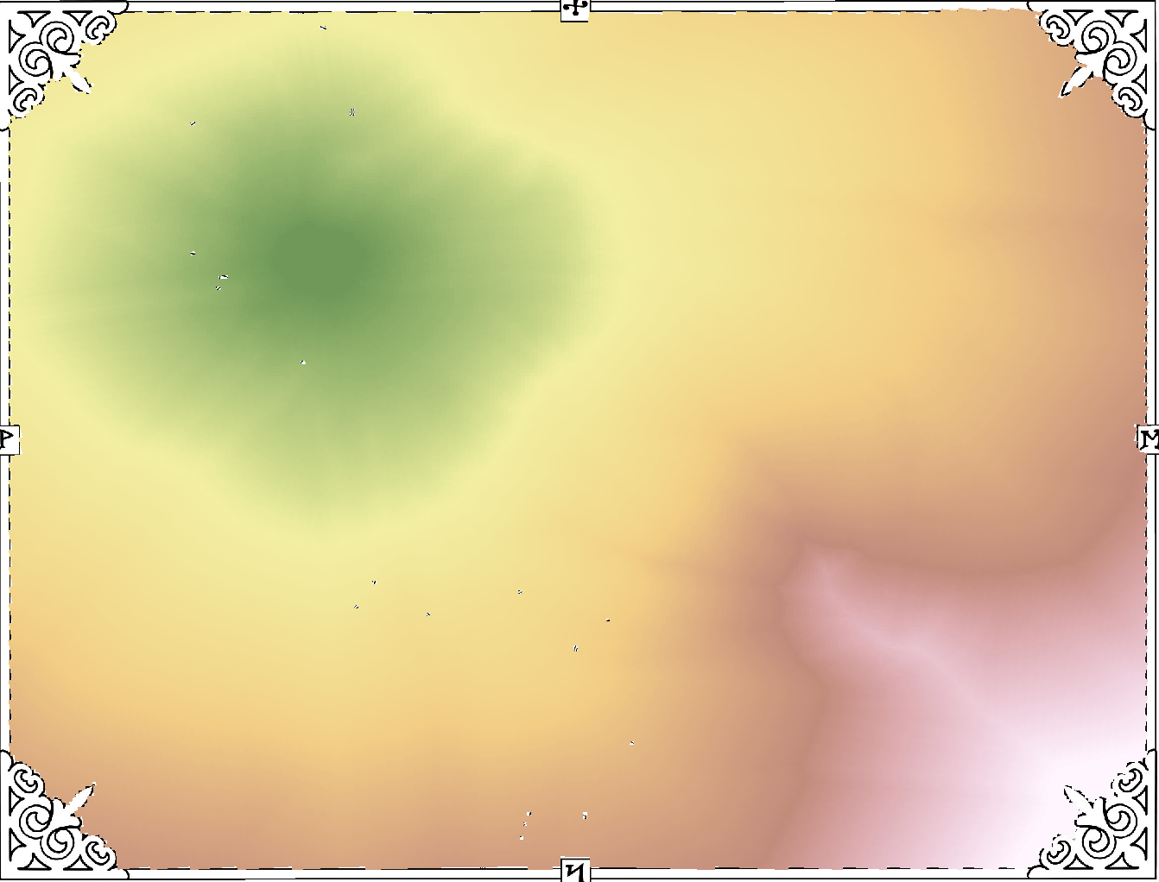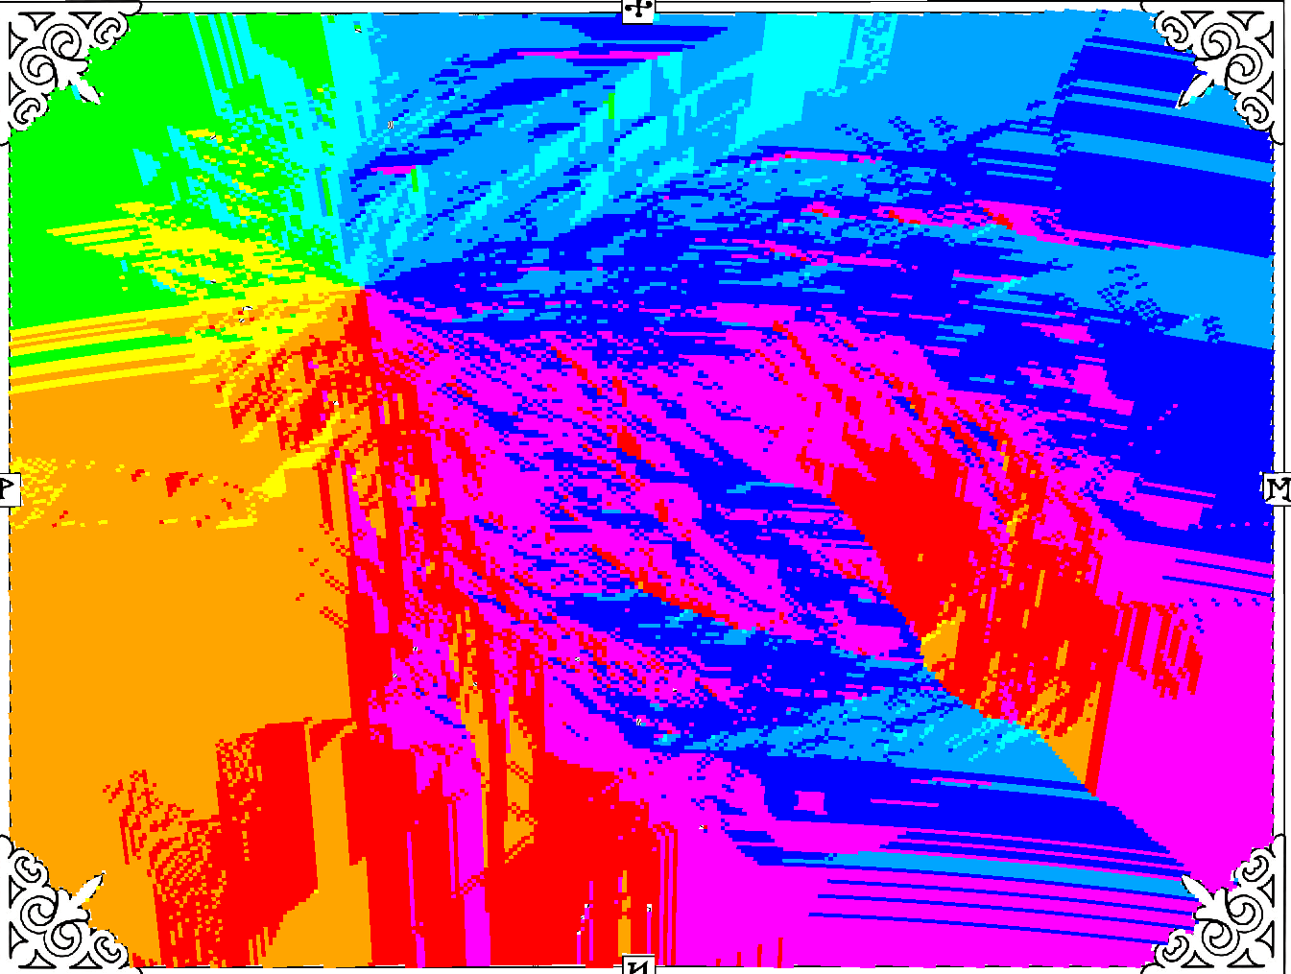

9. Use the 2 new layers you just made and the source data and put them into the “Cost Path” tool. This will give you your final map with the least cost path from the Shire to Mordor.
a. Do this first with your source data being a direct path from the Shire to Mt. Doom (start point at the shire and end point at Mt. Doom. Your input raster or feature will be the Mt. Doom point layer.
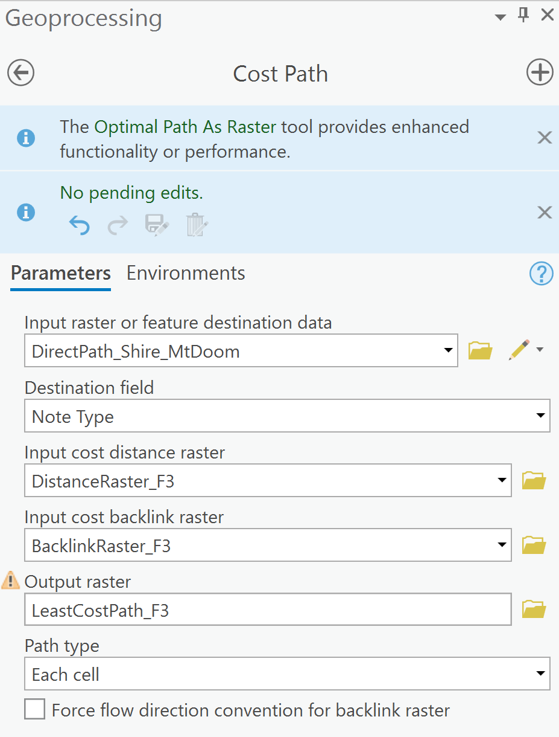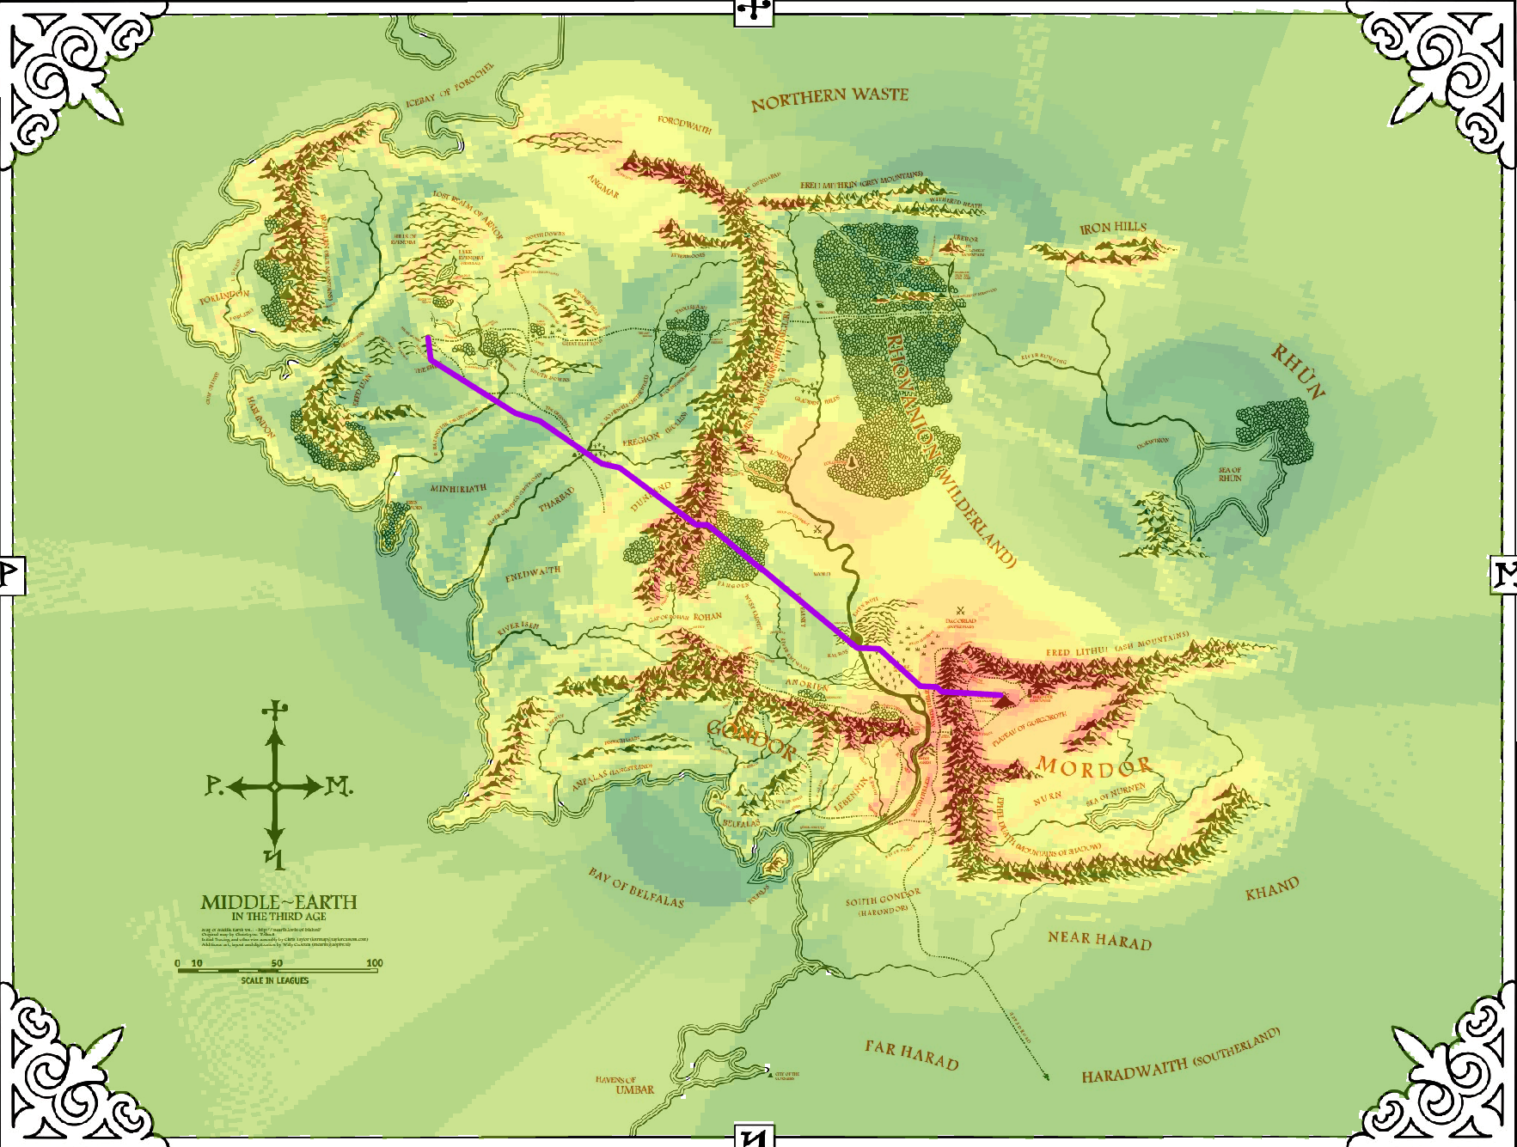

b. Next do it again but with a stop in Rivendell accounted for. Do do this you will need to use a starting point at the Shire and an end point at Rivendell run the cost path tool to get your first segment of the least cost path; then another start point at Rivendell and re-run the cost distance tool to get the least cost distance rasters from Rivendell to Mt.Doom, then run the cost path tool again to get the second segment of the least cost path.
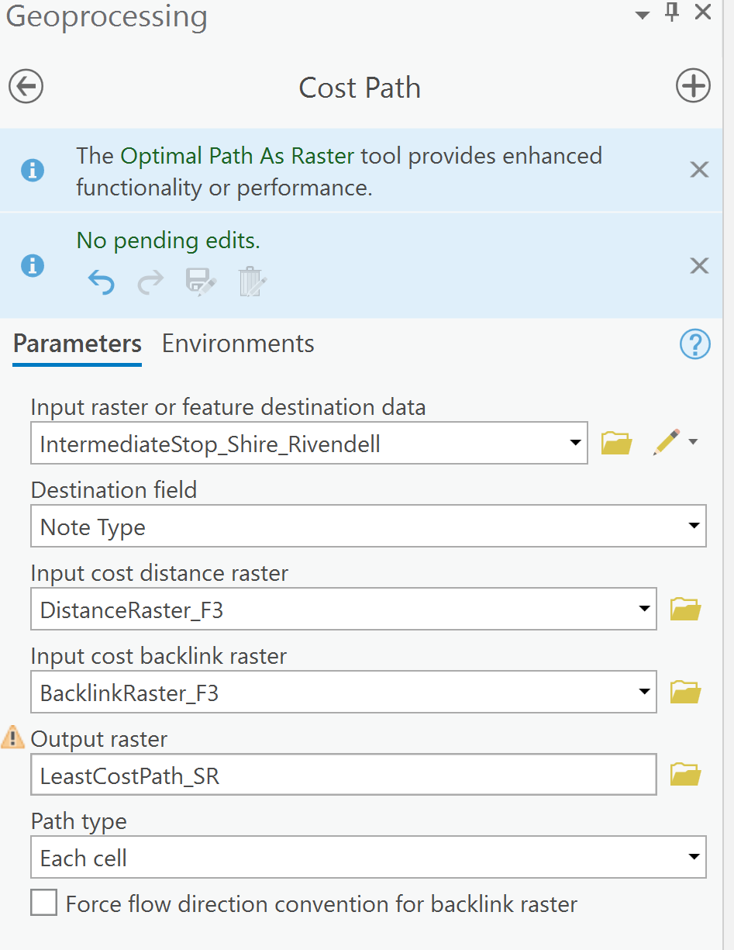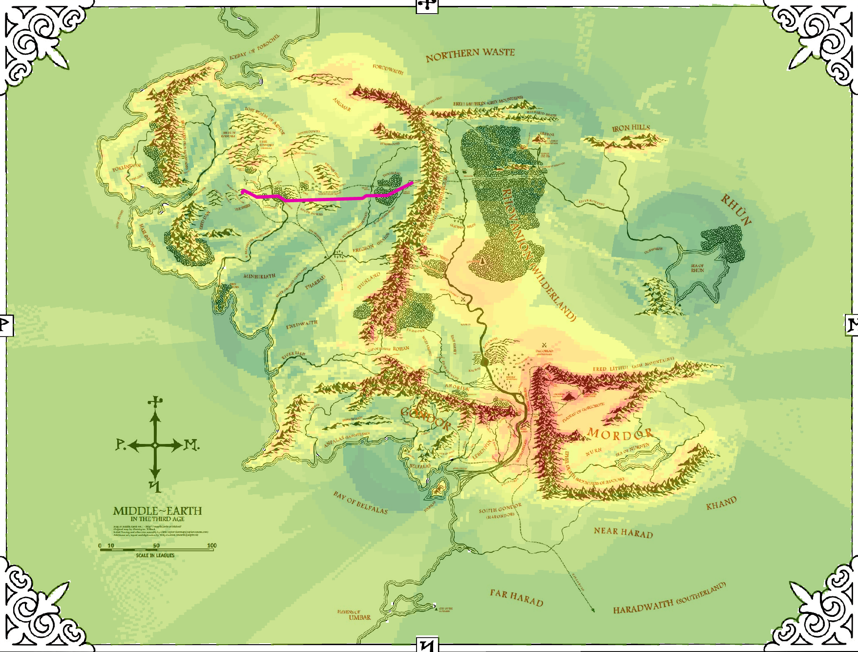
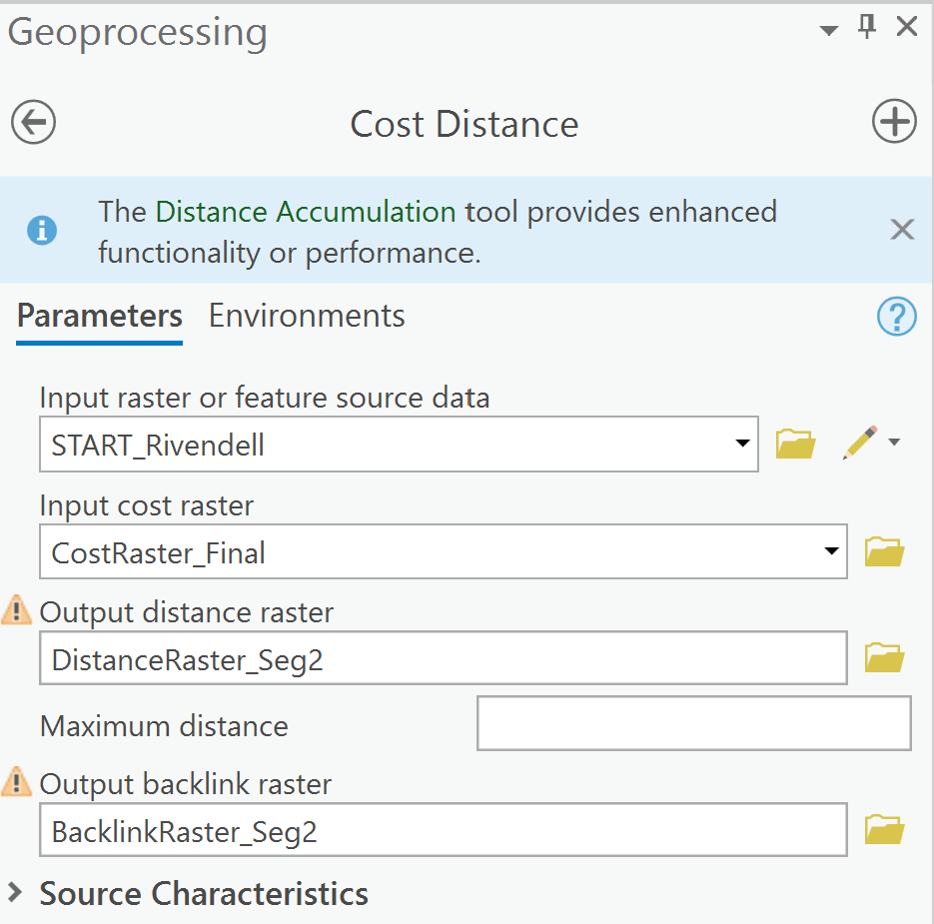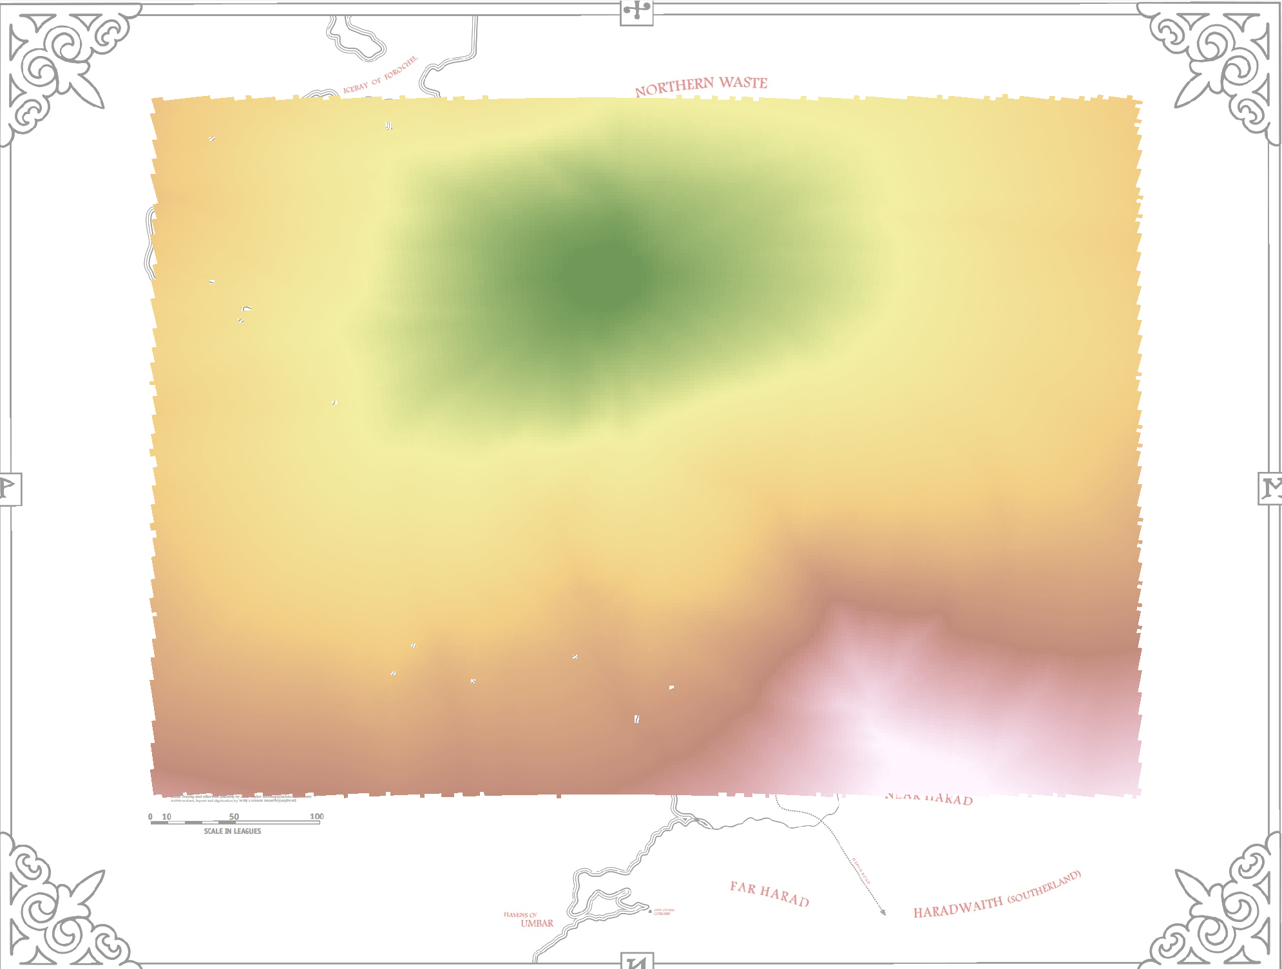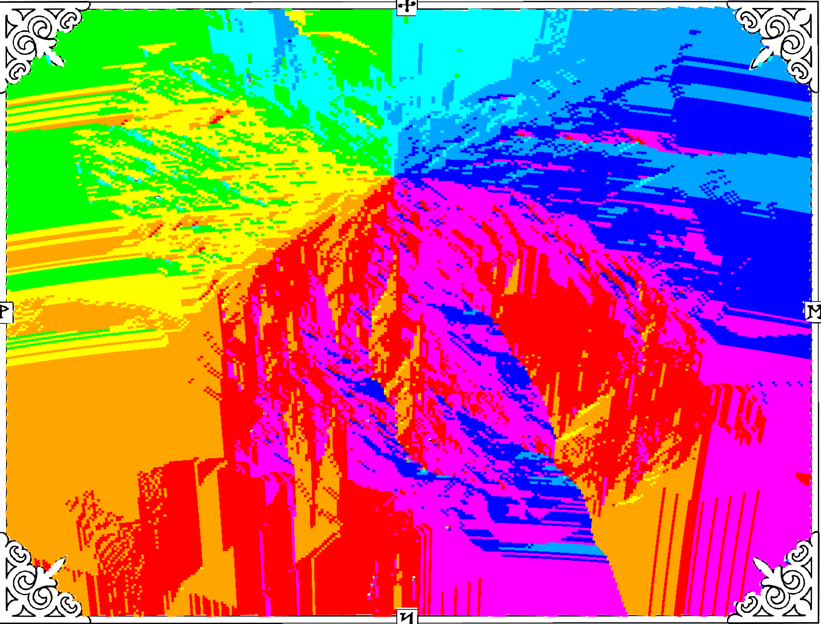
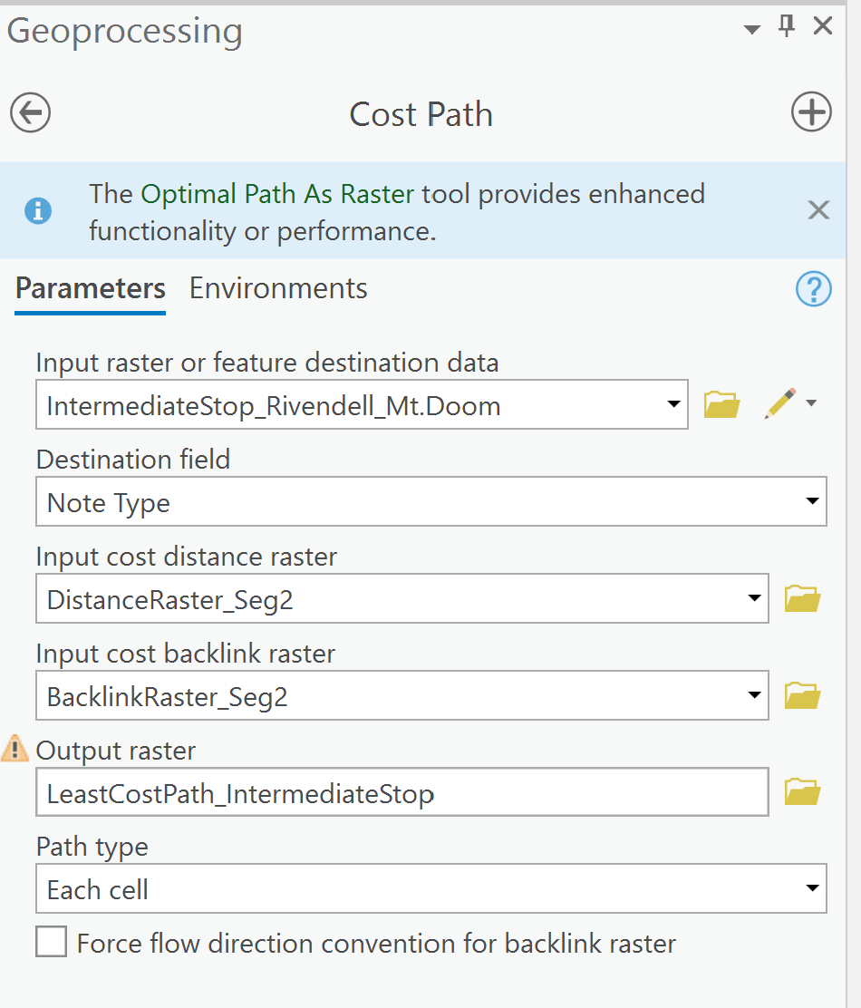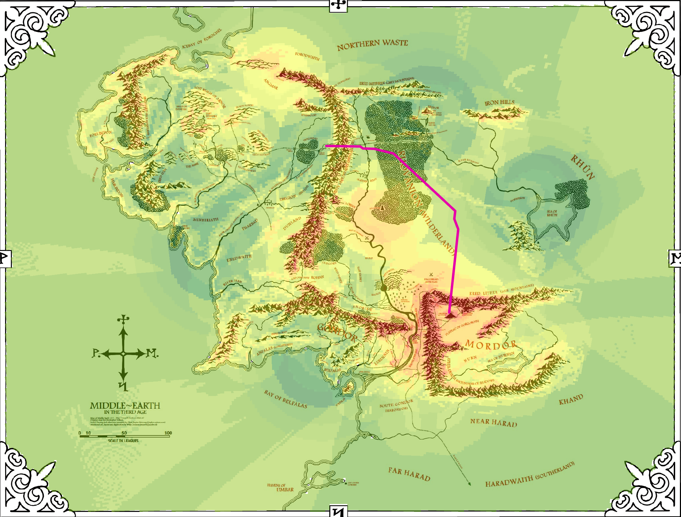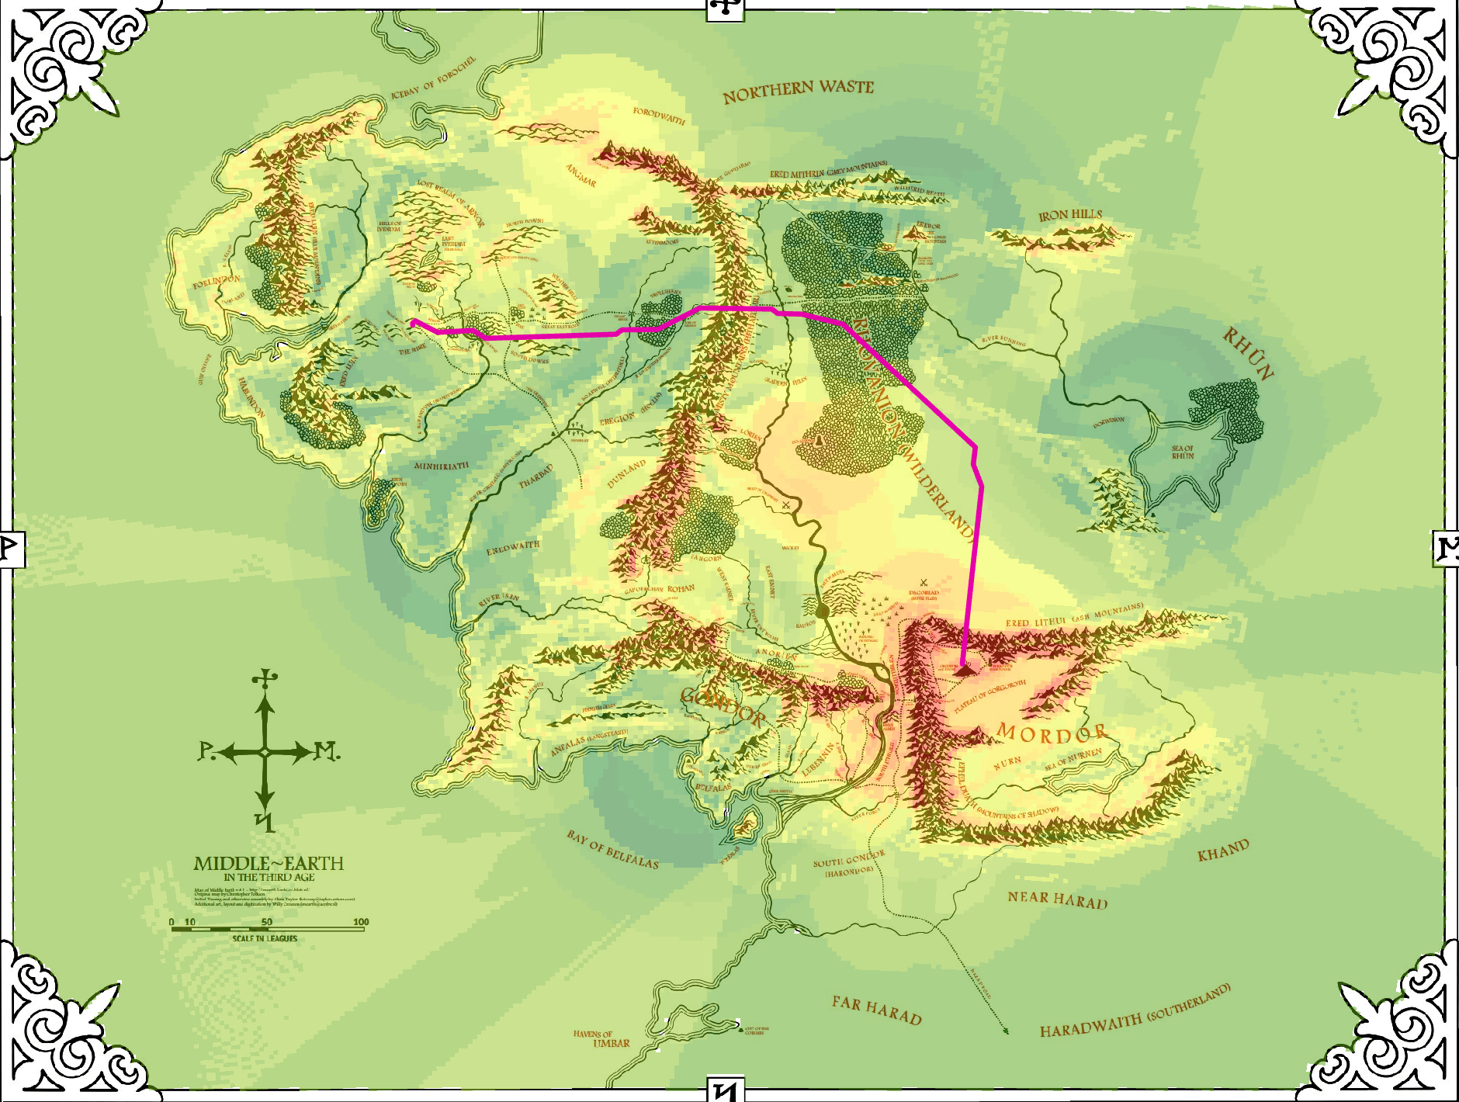

10. Make a nice map with all the usual cartographic niceties showing your total cost raster and final/original paths. Include a text box which shows the layers/weights used.

11. Now, redo the whole thing (just the second part – Shire to Rivendell and Rivendell to Mt. Doom - with significantly different weights. You should get different routes. Make a nice map of this too.

Deliverables
- Get these two maps into a word document and answer the following questions:

  - Describe in your own words why the paths you calculated were different than the paths Frodo and Sam took. And why the two paths you calculated were different.
  - What other data do you wish you had for this? In short, if you were doing this, what would you change.
  - This was your introduction to cost path analysis. Give three examples of how this sort of analysis could be used (that isn’t routing Frodo).

